d8bd820998120906e2757f1ca24b16f

*LAC100 series user manual*

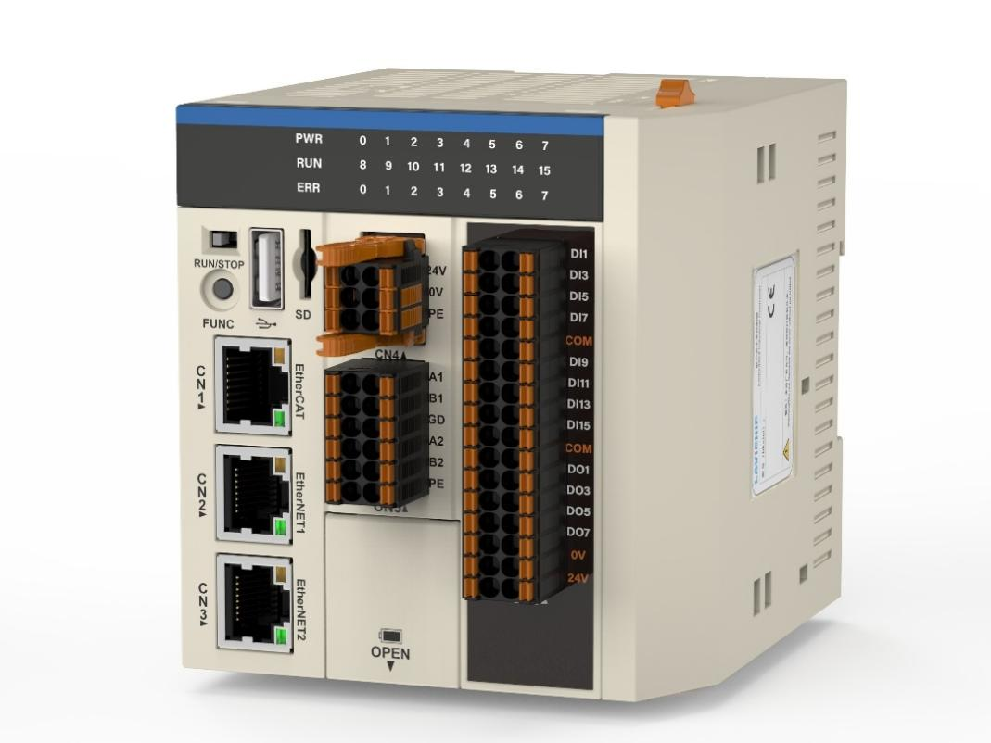

Thank you very much for purchasing our controller.

This manual records the use and maintenance of "LAC100" series controllers. Please read this manual carefully.

Then carry out the installation, wiring, use, maintenance and inspection of products. Please take good care of this manual and deliver it to the end user.

Please take good care of this manual and deliver it to the end user.

Description

The contents of the user manual may be changed without prior notice.

If you find anything suspicious, wrong or omitted in the user manual, please contact us to change it.

If there are wrong or missing pages in the user manual, we will replace them for you.

User manual of LAC100 series controller

issuer Shenzhen Langyuxin Technology Co., Ltd.

Headquarters address: 4th floor, Building B, Giant U Valley Manufacturing Innovation Park, Houting Community, Shajing Street, Baoan District, Shenzhen.

Intelligent Manufacturing Center: 6th Floor, Building 15, Haichuang Dazu Robot Manufacturing City, No.3, No.2 Industrial Avenue, Xihai Village, Beijiao Town, Shunde District, Foshan City, Guangdong Province

Telephony ： 0755-29492749

Change Record

|  |  |  |  |
| --- | --- | --- | --- |
| version | Change information | Changer | date |
| V1.0 | New edition release | lsw | 2023-03 |
| V1.1 | Change 3.2 Naming Rules and Product Pictures on Cover | lsw | 2023-06 |
| V1.2 | Change 3.8.2 wiring diagram | lsw | 2023-06 |
| V1.3 | Work environment, storage environment and protection level with 3.4 specification parameters are added. | lsw | 2023-07 |
| V1.4 | Update the specification parameters in Section 3.4 and the introduction of all functions in Section 3.1; Modify the company address and related information | lsw | 2023-10 |
| V1.5 | Update the cover product picture and company name | lsw | 2024-01 |
| V1.6 | Add LAC100-21N00 model and related information; Update the contents of chapters 3.1.2, 3.6.2, 3.6.3, 6 and 7. | czm | 2024-01 |
| V1.7 | Update 3.3 specification parameters | czm | 2024-03 |
| V1.8 | Update section 3.5.3. | skx | 2024-04 |
| V1.9 | Change Chapter 4 to Installation and Disassembly. | yxx | 2024-08 |
| V2.0 | Add section 3.7.5. | yxx | 2024-09 |
| V2.1 | In chapter 3.3, input parameters are added to the specification parameter table. | yxx | 2024-10 |
| V2.2 | Modify the definition table of digital tube instructions in Chapter 3.6, and modify the 3.5.2MicroSD card slot. | yxx | 2024-11 |
| V2.3 | Supplement 3.6 Definition Table of Digital Tube Indication | zql | 2024-11 |
| V2.4 | Browsers and versions specifically supported in Chapter 7 are supplemented. | zql | 2024-12 |

Handbook of LAC100 series controllers

The information is as follows. Please select the manual according to your needs.

|  |  |  |
| --- | --- | --- |
| serial number | Manual name | explain |
| one | LAC100 Series Controller and IO Module Selection Manual | Learn about the basic function types of controller products. |
| 2 | LAC100 series controller software starter manual | Software acquisition, installation and introductory operation tutorial |
| four | User manual of LAC100 series controller | Instructions on the basic use of LAC100 series controllers, etc. |
| five | User Manual of LAC100 Series Controller (Book) | Instructions on the basic use of LAC100 series controllers, etc. |
| six | Basic instruction manual of LAC100 series controller programming | Understanding of the concept and function of basic instructions for controller programming |
| seven | LAC100 series controller motion control instruction manual | Understanding of Basic Concepts and Functions of Motion Control Instructions |

Catalogue

[Description 1](#_Toc10155)

[Change Record 1](#_Toc4191)

[Catalogue 2](#_Toc29053)

[Chapter One Foreword 3](#_Toc16356)

[Chapter Two matters need attention 5](#_Toc29979)

[Chapter Three product information 9](#_Toc25383)

[3.1 naming rule 9](#_Toc2858)

[3.2 Product nameplate description 9](#_Toc18364)

[3.3 Specification parameter 10](#_Toc32296)

[3.4 product mix 11](#_Toc14507)

[3.5 Interface introduction and definition 12](#_Toc18747)

[3.5.1 Interface introduction 12](#_Toc2799)

[3.5.2 Interface definition 13](#_Toc4246)

[3.5.3 Introduction of interface function 15](#_Toc28809)

[3.6 Definition of digital tube indication 16](#_Toc19047)

[3.7 Definition and wiring of local IO terminal 17](#_Toc10843)

[3.7.1 Local IO interface definition 18](#_Toc29133)

[3.7.2 hookup 18](#_Toc5563)

[3.7.3 Input IO wiring diagram 18](#_Toc27281)

[3.7.4 Local extension module 19](#_Toc23519)

[3.7.5 IObus parameter description 20](#_Toc25466)

[3.7.6 Remote expansion module 23](#_Toc31046)

[Chapter Four Installation and disassembly 25](#_Toc13434)

[4.1 Wiring instructions 25](#_Toc17866)

[4.2 Communication related wiring 25](#_Toc24322)

[4.3 matters need attention 25](#_Toc10766)

[Chapter Five Module connection 26](#_Toc19010)

[5.1 Connection of power supply, controller and local I/O expansion module 26](#_Toc21839)

[5.2 Rail mounting 26](#_Toc25121)

[5.3 Use the battery and replace the battery 27](#_Toc7918)

[Chapter Six Communication connection 28](#_Toc14123)

[6.1 EtherCAT/Modbus TCP bus connection 28](#_Toc22835)

[6.2 RS232/RS485 communication connection 28](#_Toc28369)

[6.3 Monitoring connection via Ethernet 28](#_Toc18184)

[Chapter Seven Web page operation 29](#_Toc3745)

[7.1 Log on to the web 29](#_Toc13513)

[7.2 Controller information viewing, and controlling local IO. 29](#_Toc17005)

[7.3 IP settings 30](#_Toc29786)

[7.4 Application information 30](#_Toc31863)

[7.5 Application operation 31](#_Toc16160)

[7.6 System time setting 31](#_Toc2070)

[7.7 Web user operation 32](#_Toc21651)

[7.8 Firmware upgrade 32](#_Toc10868)

[7.9 Restore factory settings 33](#_Toc8827)

[7.10 Registered PLC 33](#_Toc2646)

[Chapter Eight Programming example 35](#_Toc7950)

[8.1 Preparation before programming 35](#_Toc20481)

[8.2 Create a project and make programming configuration. 35](#_Toc10243)

[8.3 Program compilation, operation and debugging 45](#_Toc18329)

1. Foreword

Thank you for purchasing LAC100 series motion control industrial PLC independently developed and produced by Shenzhen Langyuxin Technology Co., Ltd..

LAC100 controller conforms to IEC61131-3 programming specification and supports six programming languages of PLCopen standard. Commonly used industrial control interfaces such as USB, RS485, Ethernet and CAN are integrated inside. With local IO, it supports 16-channel input and 8-channel drain output. LAC100 controller supports EtherCAT, MODBUS-TCP, CANopen, EtherNet/IP, RS485, etc. for remote rack expansion, and supports more I/O points.

This manual mainly describes the specifications, parameters and usage of this product. Please read this manual carefully before use, so as to use this product more safely.

1. matters need attention

* **Safety instructions**
* Please read and observe the safety precautions before installing, operating and maintaining the product.
* To ensure personal and equipment safety, when installing, operating and maintaining the product, please follow the instructions in the product label and manual.

All safety precautions.

* The "Caution", "Warning" and "Danger" items in the manual do not represent all the safety items that should be observed, but only

It is a supplement to all safety precautions.

* This product should be used in an environment that meets the requirements of design specifications, otherwise it may cause failure, which may be caused by failure to comply with relevant regulations.
* The abnormal function or component damage of is not within the scope of product quality assurance.
* Our company will not bear any legal responsibility for personal safety accidents and property losses caused by illegal operation of products.

|  |  |
| --- | --- |
| Security level definition | |
| 图片1danger | Failure to use it according to the regulations will lead to fire, serious personal injury and even death! |
| 图片1pay attention to | Failure to use it according to regulations may lead to fire, serious personal injury and even death! |
| 图片1warn | Failure to use it according to the regulations may lead to moderate personal injury or minor injury, as well as equipment damage! |

|  |  |
| --- | --- |
| When products arrive and are stored. | |
| 图片1warn | * When unpacking, if the product and its accessories are damaged, please do not install them. Please contact our company or your supplier as soon as possible. * Carefully check whether the arrived products are consistent with the ordered product models and whether the products and product accessories are complete. |
| 图片1  fill  idea | * Please do not stack this product too much, otherwise it will lead to injury or failure. * Please do not store it in direct sunlight, where the ambient temperature exceeds the storage temperature, where the relative humidity exceeds the storage humidity, where the temperature difference is large, where condensation occurs, where corrosive gases and flammable gases are close, where dust, dust, salt and metal dust are abundant, where water, oil and drugs drip, or where vibration or shock can be transmitted to the main body, otherwise it will lead to fire, electric shock or machine damage. * Please do not hold the cable or motor shaft for handling, otherwise it will lead to injury or failure. |

|  |  |
| --- | --- |
| System design time | |
| 图片1danger | * When the rated load current is exceeded or the load is short-circuited for a long time, the product may smoke or catch fire, and safety devices such as fuses or circuit breakers should be set outside. |
| 图片1warn | * Please be sure to design a safety circuit to ensure that the product system can still work safely when the external power supply fails or the product fails. * In order to make the equipment run safely, please design external protection circuit and safety mechanism for the output signals related to major accidents. |
| 图片1  fill  idea | * Be sure to set emergency braking circuit, protection circuit, interlock circuit for forward and reverse operation and interlock switch for upper and lower limit positions to prevent machine damage in the external circuit of the product. * The product may shut down all outputs after detecting its own system abnormality; When some circuits of the controller fail, the output may be out of control. In order to ensure normal operation, it is necessary to design appropriate external control circuits. * When the relay, transistor and other output units of the product are damaged, the output can not be cONtrolled to be on or OFF. * The product is designed to be used indoors and in an electrical environment with overvoltage level II, and its power system level should be equipped with lightning protection devices to ensure that lightning overvoltage is not applied to the power input, signal input, control output and other ports of the product to avoid damaging the equipment. |

|  |  |
| --- | --- |
| When the product is installed | |
| 图片1dangerous  dangerous | * Only professional maintenance personnel who have been trained in electrical equipment and have sufficient electrical knowledge can install this product. * For open equipment, please install it in the control cabinet with door lock (product cabinet shell protection > ＞IP20). Only operators who have been trained in electrical equipment and have sufficient electrical knowledge can open the product cabinet. |
| **图片1**  **police**  **tell** | * When disassembling the product, all external power supplies used by the system must be disconnected before operation. If the power supply is not completely disconnected, it may lead to electric shock or product failure and misoperation! * When the power supply of the drive product is turned off for more than 5 minutes, and the power indicator lamp is turned off, the control power supply is turned off, and then the drive product is disassembled. Otherwise, you will get an electric shock due to residual voltage. * Please do not use the product in the following places: places with dust, oil fume, conductive dust, corrosive gas and flammable gas; Exposure to high temperature, condensation, wind and rain; There are occasions of vibration and impact. Electric shock, fire and misoperation can also lead to product damage and deterioration! |
| **图片1fill**  **idea** | * When installing, avoid metal chips and wire ends falling into the vent hole of the product, which may cause fire, failure and misoperation. * After installation, ensure that there are no foreign objects on the ventilation surface, otherwise it may lead to poor heat dissipation and cause fire, failure and misoperation. * When installing, it should be closely connected with their respective connectors, and the product connection hook should be firmly locked. If the product is improperly installed, it may lead to misoperation, failure and falling off. |

|  |  |
| --- | --- |
| When wiring products | |
| 图片1danger | * Only professional maintenance personnel who have been trained in electrical equipment and have sufficient electrical knowledge can wire this product. |
| 图片1police  tell | * During wiring operation, all external power supplies used by the system must be disconnected before operation. If it is not completely disconnected, it may lead to electric shock or equipment failure and misoperation. * The terminal cover attached to the product must be installed when the wiring operation is powered on and running. If the terminal cover is not installed, it may cause electric shock. * Confirm the connected interface type before connecting the cable correctly. If the wrong interface is connected or the wiring is wrong, the product and external equipment may fail. * Cable terminals should be insulated to ensure that the insulation distance between cables will not be reduced after the cables are installed on the terminal block. Otherwise, it will cause electric shock or equipment damage. * When wiring, avoid metal chips and wire ends falling into the ventilation hole of the controller, which may cause fire, failure and misoperation! * Tighten the bolts on the terminal block within the specified torque range. The terminal bolts are not tightened, which may lead to short circuit, fire or misoperation. Tightening bolts may damage bolts and products, resulting in falling off, short circuit, fire or misoperation. |
| pay attention to图片1 | * The specifications and installation methods of external wiring of equipment shall meet the requirements of local distribution laws and regulations. * In order to ensure the safety of equipment and operators, the equipment needs to be reliably grounded with cables with sufficient wire diameter. * For the connection between connectors and external equipment, press-fitting, press-bonding or proper welding shall be carried out with tools specified by the manufacturer. If the connection is poor, it may lead to short circuit, fire or misoperation. * If the product is labeled to prevent foreign objects from entering, prevent foreign objects such as wiring heads from entering the product during wiring. Do not tear off this label during wiring work. Before starting the system operation, be sure to tear off the label to facilitate heat dissipation. * Do not bind the control line and communication cable with the main circuit or power supply line, and the wiring should be more than 100mm apart, otherwise the noise may lead to misoperation. * For applications with serious interference, please choose shielded cables for the input or output cables of high-frequency signals to improve the anti-interference ability of the system. |

|  |  |
| --- | --- |
| Before the product is electrified. | |
| **图片1**  **dangerous**  **dangerous** | * Before electrifying, please confirm that the product is installed in good condition, the wiring is firm, and the motor device is allowed to restart. * Before electrifying, please confirm that the power supply meets the product requirements to avoid product damage or fire. * It is strictly prohibited to open the product cabinet door or product protective cover, touch any terminal of the product, or remove any device or parts of the product when it is electrified, otherwise there is a danger of electric shock. * Before powering on, please ensure that there are no people around the products, motors and machinery, otherwise it may lead to personal injury or death! |
| 图片1warn | * After the wiring operation and parameter setting are completed, please carry out the trial operation of the machine to confirm that the machine can operate safely, otherwise it may cause personal injury or equipment damage! * Please ensure that the rated voltage of the product is consistent with the power supply voltage before powering on. If the power supply voltage is used incorrectly, there will be a danger of fire! |

|  |  |
| --- | --- |
| During operation and maintenance | |
| **图片1**  **dangerous**  **dangerous** | * Only professional maintenance personnel who have been trained in electrical equipment and have sufficient electrical knowledge can run the product.   Maintenance.   * Do not touch the terminal when it is energized, otherwise it may lead to electric shock or misoperation. * When the motor and equipment are running, please never touch their rotating parts, otherwise it may lead to serious personal safety accidents. |
| **图片1**  **police**  **tell** | * When cleaning the product or re-fastening the bolts on the terminal strip and the connector mounting bolts, the external power supply used by the system must be completely disconnected. Otherwise, you may get an electric shock. * When disassembling products or connecting or removing communication cables, all external power supplies used by the system must be disconnected first. If not completely disconnected, it may lead to electric shock or misoperation. * When the power supply of the drive product is turned off for more than 5 minutes, and the power indicator lamp is turned off, the control power supply is turned off, and then the drive product is disassembled. Otherwise, you will get an electric shock due to residual voltage. |
| 图片1fill  idea | * For online modification, forced output, RUN, STOP and other operations, you must read the user manual carefully and confirm its safety before carrying out related operations. * Please cut off the power supply before loading and unloading expansion cards, modules and other components! |

|  |  |
| --- | --- |
| When the product is scrapped | |
| 图片1pay attention to | * Please treat it as industrial waste; Discarding batteries should be carried out separately according to the laws and regulations formulated by various regions, so as to avoid property losses or casualties! * Scrap products should be treated and recycled according to industrial waste treatment standards to avoid environmental pollution. |

2. product information

LAC100 series products are a medium-sized programmable controller with modular structure design. Each rack supports local expansion of 16 expansion modules, and the rack can be extended remotely through various industrial field buses such as EtherCAT, CANopen and EhterNet/IP. The local expansion module carries out IO expansion through the internal bus protocol, and supports digital input/output module, analog input/output module, temperature module and remote function module. Among them, the analog input/output module adopts 16-bit resolution conversion chip, which further improves the signal conversion accuracy; The motion control function is realized by EtherCAT bus; The execution cycle of 2ms supports 16-axis motion control, and has the functions of single-axis acceleration and deceleration control, electronic gear function and electronic cam function.

* 1. naming rule

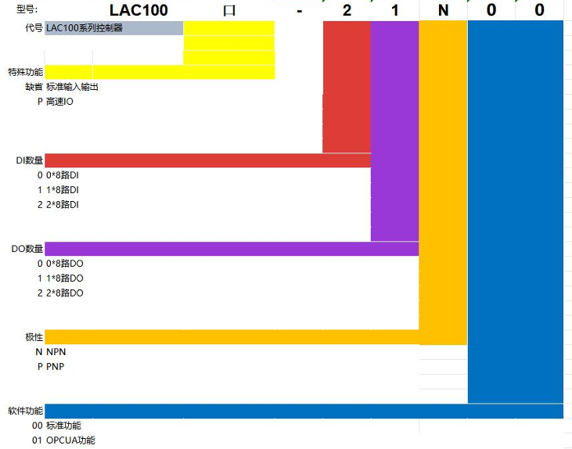

* 1. Product nameplate description

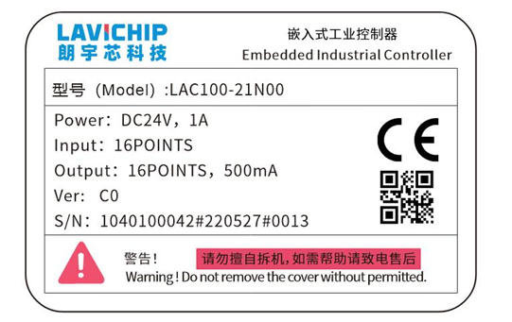

* 1. Specification parameter

| model | | LAC100-21N00 | LAC100-21N01 |
| --- | --- | --- | --- |
| Power Supply | Power supply | Two groups of 24 VDC (-15% ~ 20%) | |
| Rated input current (excluding I/O current) | 500mA | |
| Rated power (excluding I/O) | [12W](mailto:500mA@24VDC) | |
| Basic hardware | CPU frequency | 4-core 1.2GHz | |
| memory | 1GB | |
| Net mouth | 1\*1000Mbps+2\*100Mbps | |
| USB | 1xUSB2.0 | |
| data | Program capacity | 128MB | |
| data capacity | 128MB | |
| Power-off holding mode | Capacitor power-off storage | |
| Power-down hold variable memory | 256KB | |
| EtherCAT | quantity | 1x100Mbps | |
| Tape shaft performance | 2ms period 16-axis synchronization | |
| Minimum task cycle | 1ms | |
| protocol | EtherNET/IP master station | √ | |
| EtherNET/IP slave station | √ | |
| OPCUA | × | √ |
| ModbusTCP master station \ client | 2 road  16 slave stations \ servers are recommended for each route. | |
| ModubsTCP slave station \ server | √ | |
| RS485 serial port | Two channels support ModbusRtu master station (16 slave stations are recommended for each channel), ModbusRtu slave station and free protocol. | |
| RS232 serial port | 1 channel supports ModbusRtu master station (16 slave stations are recommended for each channel), ModbusRtu slave stations and free protocols. | |
| CAN | 1 road  Support CAN protocol and CANOPEN protocol. | |
| EMC and environmental reliability | EMC | CE | |
| working environment | Working temperature:-－10ºC ~ 55ºC, working humidity: 5% ~95% (no condensation). | |
| Storage environment | Storage temperature:-40 C ~ 80 C, storage temperature: 5% ~95% (no condensation) | |
| Working altitude | 2000m | |
| ingress protection | IP20 | |
| 输入参数 | input impedance | 8.6kΩ | |
| ON input voltage range | ≥15V DC | |
| OFF input voltage range | ≤5V DC | |

* 1. product mix

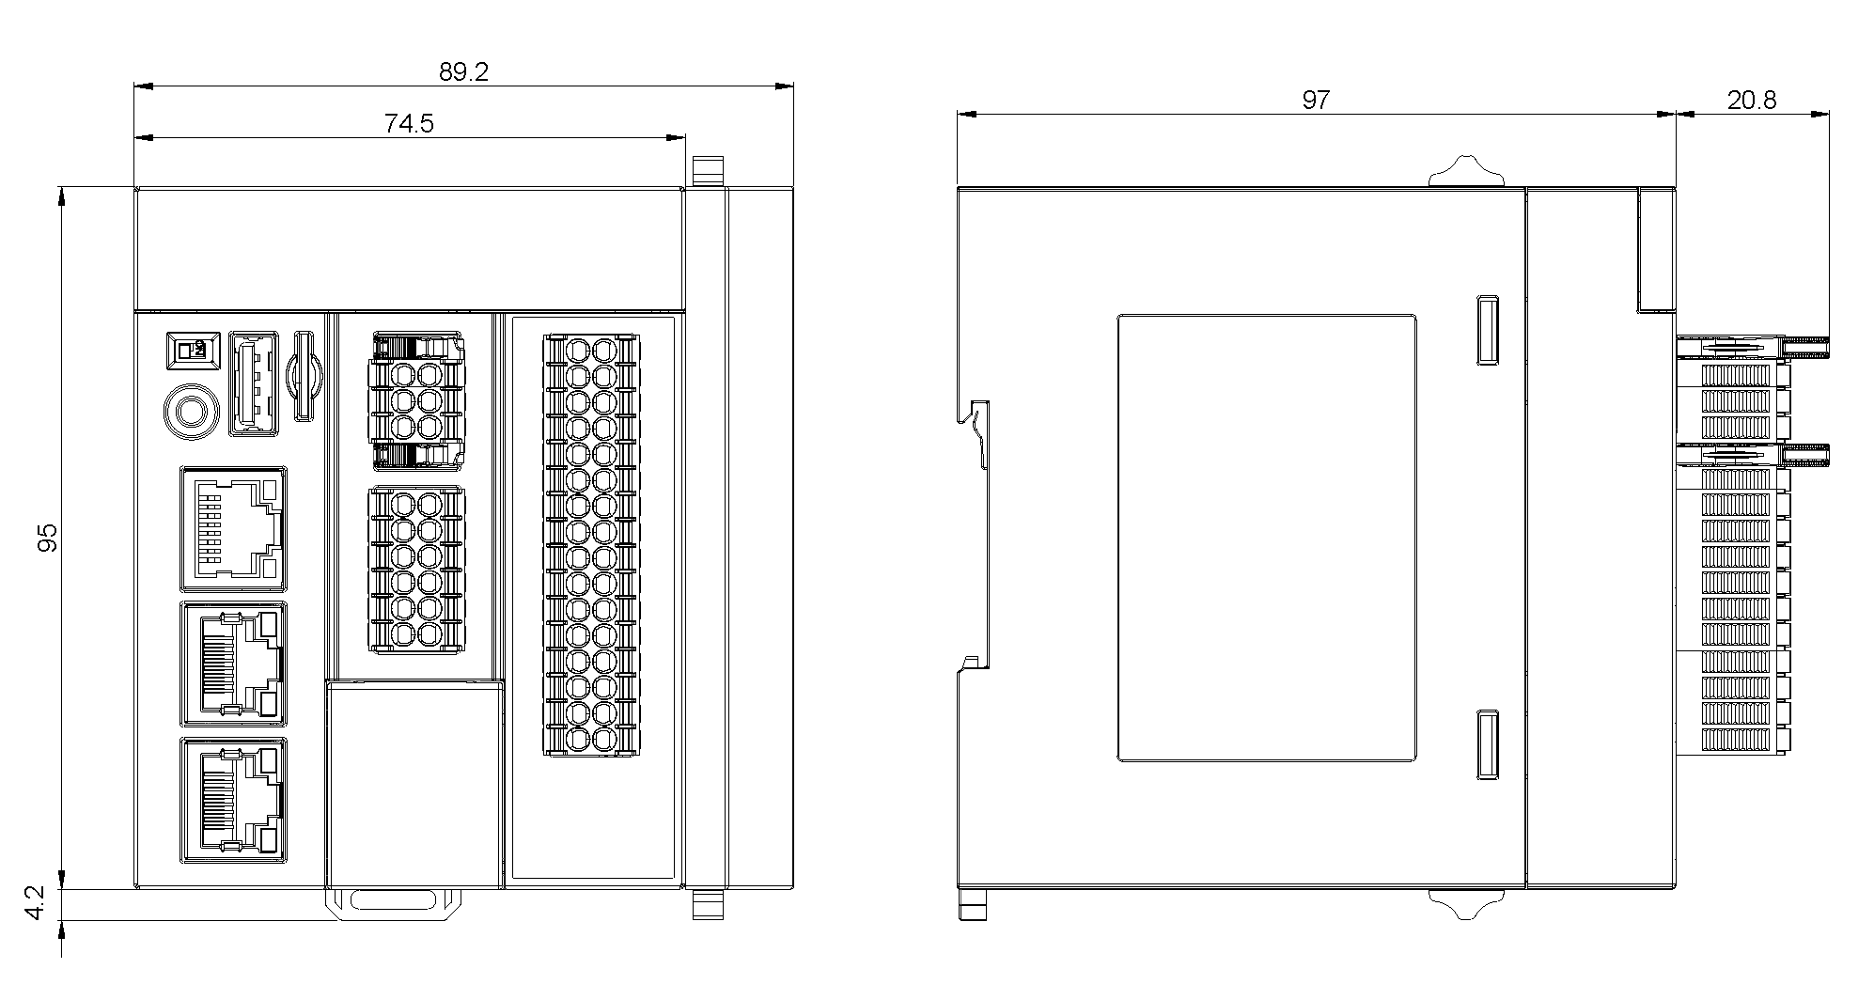

Figure LAC100-21N00 External dimension drawing of LAC100-21N00

* 1. Interface introduction and definition
     1. Interface introduction

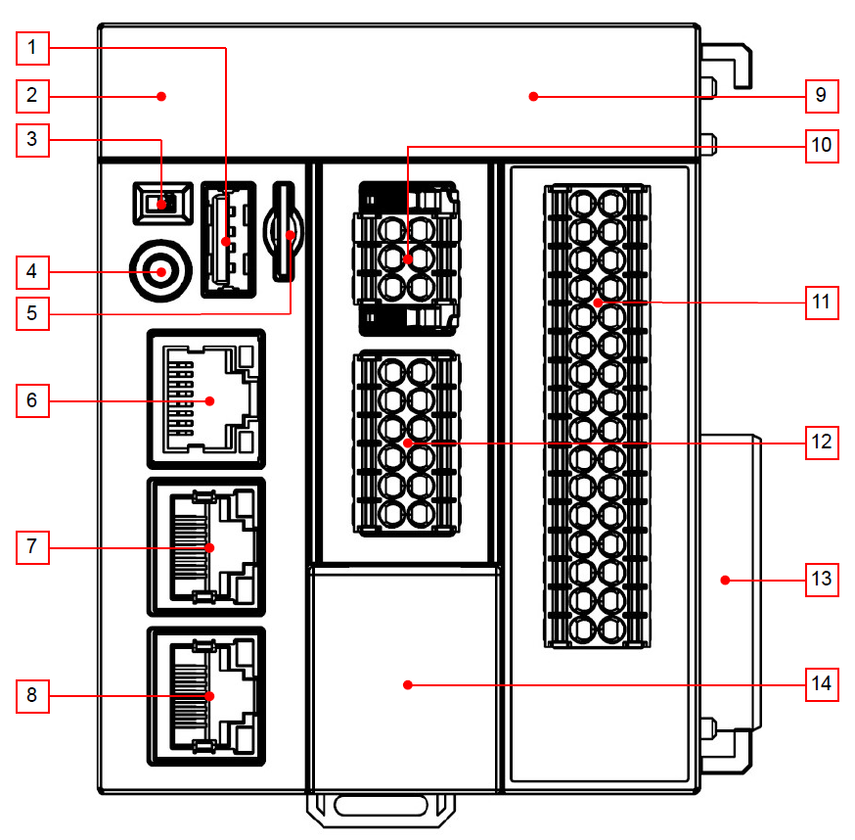(1) USB interface

(2) Digital tube indication

(3) RUN/STOP switch

(4) FUNC function button

(5) MicroSD card slot

(6) EtherCAT interface

(7) Ethernet1 interface

(8) Ethernet2 interface

(9) LED indicator light

(10) CPU module power supply interface

(11) Local IO terminal

(12) RS232/RS485 and CAN interface

(13) Backplane bus interface

(14) Battery box

Fig. interface schematic diagram of LAC100-21N00 and LAC100-21N01 modules.

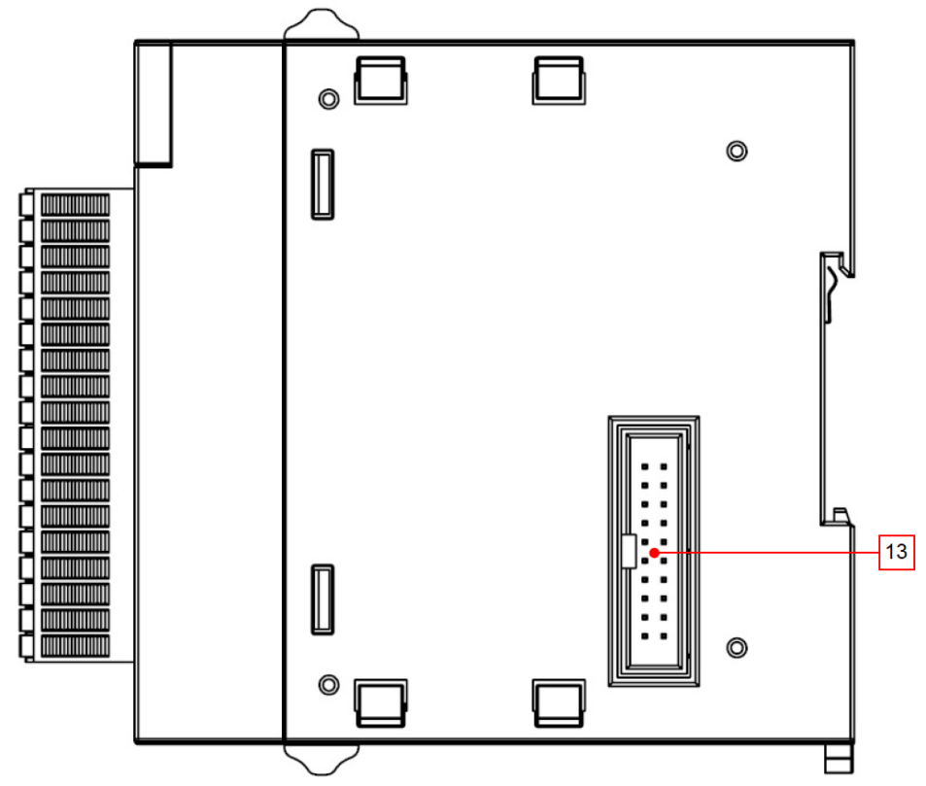

(13) Backplane bus interface

* + 1. Interface definition

|  |  |  |
| --- | --- | --- |
| number | Interface name | Function definition |
| one | Usb interface | On-site maintenance and debugging (other functions can be customized according to users' needs, such as USB expansion network card, USB Wifi module, USB authorization module, etc.) |
| 2 | Nixie tube | Display operation status and fault information (refer to 3.7 Definition of Digital Tube Indication for details). |
| three | RUN/STOP | Program RUN/STOP switch |
| four | FUNC key | Multifunctional key |
| five | MicroSD card slot | It can be extended to 32G MicroSD card, which is used for firmware update, application and data storage (not open to the public). |
| six | EtherCAT interface | 1 100M/1000Mbps(EtherCAT) adaptive Ethernet interface;  Support EtherCAT protocol; |
| 7-8 | Ethernet1/Ethernet2 interface | 2 independent 10/100Mbps(EtherNET1/ EtherNET2),  EtherNET 1:192.168.1.92,  EtherNET 2:192.168.2.92;  Support Ethernet(Modbus TCP) protocol; |
| nine | light emitting diode | Refer to 3.6.3 Interface Function Introduction for detailed definition. |
| 10 | CPU module power supply interface | 24VDC power input of CPU |
| 11 | Local IO terminal | Local IO I/O wiring (refer to 3.8 for detailed terminal definition) |
| twelve | RS232、RS485、CAN | RS232/RS485 interface, supporting Modbus protocol.  CAN interface, supporting CANopen protocol.  Standard 1 RS232, 2 RS485 and 1 CAN；; |
| 13 | Backplane bus interface | Up to 8 IO modules can be expanded when adapting to K0 series IO. |

* Description of CPU module power supply interface

|  |  |  |  |  |
| --- | --- | --- | --- | --- |
| number | name | type | function | hookup |
| 10 | 24V | input | 24V DC input | input  output |
| 0V | input | DC input ground |
| PE | Protective grounding | Protective grounding, can be connected to metal casing. |
| 24V | output | 24V DC output |
| 0V | output | DC output ground |
| PE | Protective grounding | Protective grounding, can be connected to metal casing. |

* (RS232, RS485, CAN) Port Definition Description

|  |  |  |  |  |
| --- | --- | --- | --- | --- |
| number | post | type | function |  |
| twelve | H | CAN | High potential signal of CAN0 | /tmp/webword_474479705/upload_post_object_v2_024822527  Figure CN5 port definition |
| L | Low potential signal of CAN0 |
| GD | Signal ground | CAN0 signal ground |
| TX | RS232 | COM1,RS232 transmitter |
| RX | COM1,RS232 receiver |
| GD | Signal ground | RS232 signal ground |
| A1 | RS485 | COM2,RS485 positive terminal |
| B1 | COM2,RS485 negative terminal |
| GD | Signal ground | RS485 signal ground |
| A2 | RS485 | COM3,RS485 positive terminal |
| B2 | COM3,RS485 negative terminal |
| PE | Protective grounding | Protective grounding, metal casing capable of being connected with signal cable shielding layer |

* Ethernet port indicator light

|  |  |  |  |  |
| --- | --- | --- | --- | --- |
| Indicator light | function | colour | condition | describe |
| lQLPJyFNc6zXQdLNAXbNAUGw_k7sAPZOxLMENOltNkDMAA_321_374 | Act | yellow | Changliang | Connected |
| glimmer | Connected and receiving and sending data |
| Constant extinction | Not connected |
| Link | green | Changliang | 100/Mbps connection |
| Constant extinction | Not connected |

* + 1. Introduction of interface function

1. RUN/STOP switch

By switching on or off the runtime, it is convenient to operate a single IO point through the web page on site and judge whether the IO point is normal or not.

1. FUNC key
2. When dip switch dials RUN, press the multifunction button to display IP;
3. When dip switch dials STOP, press the multifunction button to enter the menu, and long press to execute the corresponding function;

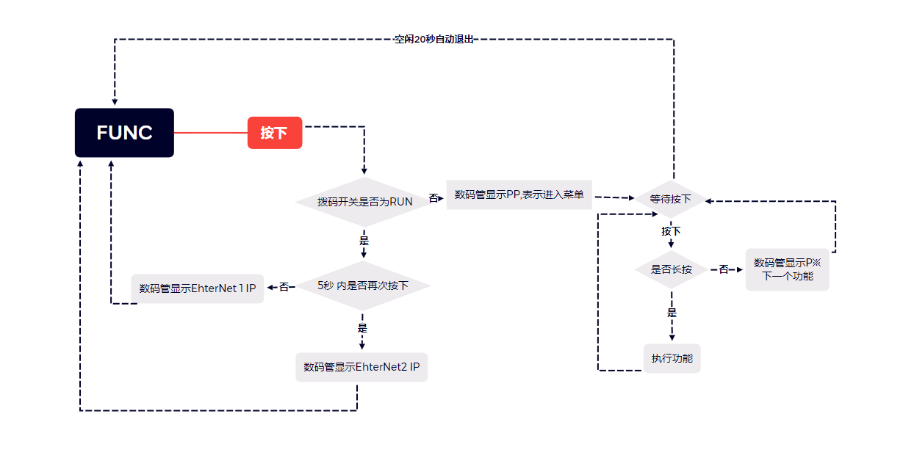

* Function:

1. P0: IP is restored to factory settings.
2. P1: Import user programs and recipe files:

After the offline program is generated by CODESYS project, put the Application.app and Application.crc files in the newly-built Application folder, and then put the Application folder in the root directory of the U disk.

1. Create a new recipes folder, and create two new folders in the file. A new recipe file named recipes\_new is stored in this folder, and the other is named recipes\_old; Then create a new configuration file named recipes with ini suffix, and indicate the formula name to be updated in the file as follows:

[RECIPESDIR]

Plccipesdir=xxxxxx

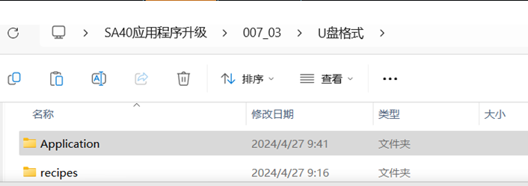

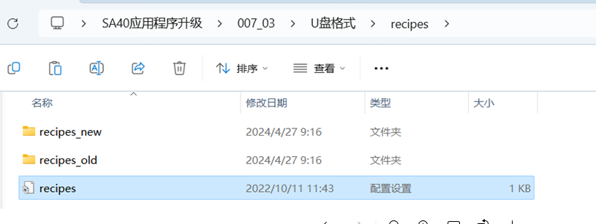

Note: Only the default program name Application is supported, and the folder name cannot be modified;

P2-P6: Reservation

P7: Upgrade the firmware, just put the file with the. des suffix provided by the supplier in the root directory of the U disk, and it will automatically restart after the upgrade;

Note: You can't put more than one firmware on the USB flash drive. If there are more than one firmware, the first file obtained shall prevail.

P8: Delete user program

P9: Delete program user

Pa: Restore factory settings (IP reset, clear application, user configuration, etc.)

After the factory settings are restored, the system will automatically restart, and the network information is:

EtherNET1： IP 192.168.1.92 | Mask 255.255.255.0 | Gateway 192.168.1.1

EtherNET2： IP 192.168.2.92 | Mask 255.255.255.0 | Gateway 192.168.2.1

EtherCAT ： IP 192.168.0.92 | Mask 255.255.255.0 | Gateway 192.168.0.1

1. Function description of EtherNET 1, EtherNET 2 and EtherCAT

|  |  |
| --- | --- |
| Net mouth | function |
| EtherCAT | Support EtherCAT protocol, which is used to expand rack or remote EtherCAT IO module and third-party EtherCAT slave equipment. |
| Ethernet1 | Modbus TCP master/slave protocol is used to download and debug programs, expand remote racks, and connect other industrial configuration systems. |
| Ethernet2 |

1. ED indicator function description

|  |  |  |  |
| --- | --- | --- | --- |
| Indicator light | function | condition | meaning |
| PWR | Power supply indication | Changliang | Normal power supply |
| put out | There is no power supply. |
| RUN | Program running instruction | Changliang | The program runs normally |
| put out | The program stops running |
| ERR | Error indication | Changliang | mistake |
| glimmer | The program is abnormal. |
| put out | normal |
| 0…7  8…15 | The last set of 0…15 marks 0…15DI input; The next set of 0…7 marks 0…15DO output; | Changliang | The channel has input/output. |
| put out | Channel has no input/output. |

* 1. Definition of digital tube indication

|  |  |  |
| --- | --- | --- |
| Digital tube display status | meaning | counter-measure |
|  | EtherCAT slave ECAT communication error | Check whether the hardware link of the slave station is connected normally. After locking the wrong slave station, you can check the error information of the digital tube on the slave station to analyze the specific error. |
| C3 | EtherCAT slave fault | 1. Check whether the EtherCAT slave station is faulty; 2. Check whether the network cable is connected normally; 3. The controller networking configuration is inconsistent with the actual networking. |
| C4 | CAN master station error | Check CANopen manager |
| C5 | CAN slave error | Check CANopen local device |
| C6 | Ethernet/IP local adapter communication error. | Check whether the IP of the network adapter is correct. |
| C7 | Ethernet/IP module communication error | Check whether the EDS file of the remote module is correct. |
| C8 | Local IO module failure | 1. Check whether the module configuration is consistent with the actual situation. 2. Check the module for communication errors. |
| C9 | Backplane bus fault | See the error ID of the master station for details. |
| 5A | PLC program stop | The PLC program is in a stopped state, waiting to be started. |
| 5B | Abnormal PLC program | Check whether the program is divided by zero or null pointer, etc. |
| 00 | The PLC program runs normally. | - |
| A0 | There is no PLC program. | 1. Check whether dip switch is in the "RUN" position.  2. You need to download the program |
| E0 | Program scheduling exception | Check whether the program is overloaded, and if it is overloaded, increase the task cycle. |
| E1 | Controller not activated. | Please contact our technicians. |
| E2 | EtheCAT does not match the model. | The number of EtherCAT axes is out of the range specified by the controller model. |
| SS | UPS trigger | Power-down signal detected |
| H0 | CPU0 load display | The load of CPU0 exceeds 80%, which may be risky. Please check the program and reasonable task configuration. |
| H1 | CPU1 load display | The load of CPU1 exceeds 80%, which may be risky. Please check the program and reasonable task configuration. |
| H2 | CPU2 load display | The load of CPU2 exceeds 80%, which may be risky. Please check the program and reasonable task configuration. |
| H3 | CPU3 load display | The load of CPU3 exceeds 80%, which may be risky. Please check the program and reasonable task configuration. |

Note: The code displayed by the digital tube represents the hexadecimal error code.

* 1. Definition and wiring of local IO terminal
     1. Local IO interface definition

|  |  |  |  |
| --- | --- | --- | --- |
| Terminal number | function | Terminal number | function |
| DI0 | Input (IN0) | DI1 | Input (IN1) |
| DI2 | Input (IN2) | DI3 | Input (IN3) |
| DI4 | Input (IN4) | DI5 | Input (IN5) |
| DI6 | Input (IN6) | DI7 | Input (IN7) |
| COM | Input common terminal | COM | Input common terminal |
| DI8 | Input (IN8) | DI9 | Input (IN9) |
| DI10 | Input (IN10) | DI11 | Input (IN11) |
| DI12 | Input (IN12) | DI13 | Input (IN13) |
| DI14 | Input (IN14) | DI15 | Input (IN15) |
| COM | Input common terminal | COM | Input common terminal |
| DO0 | 0V output (OUT0) | DO1 | 0V output (OUT1) |
| DO2 | 0V output (OUT2) | DO3 | 0V output (OUT3) |
| DO4 | 0V output (OUT4) | DO5 | 0V output (OUT5) |
| DO6 | 0V output (OUT6) | DO7 | 0V output (OUT7) |
| 0V | Output common terminal (connected to 0V) | 0V | Output common terminal (connected to 0V) |
| 24V | Output common terminal (connected to 24V) | 24V | Output common terminal (connected to 24V) |

* + 1. hookup

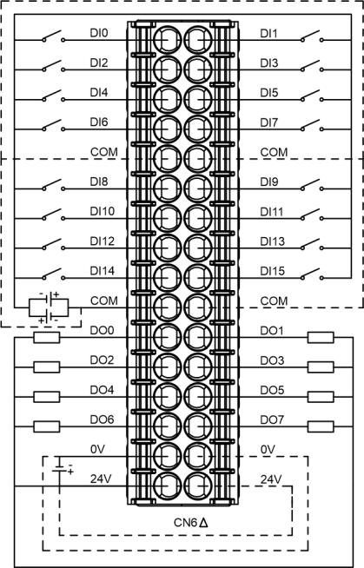

* + 1. Input IO wiring diagram

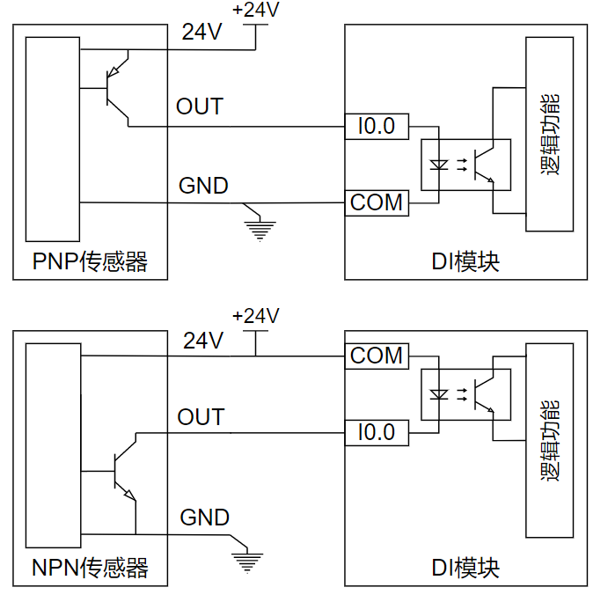

Note: The body IO is NPN drain output, and the controller field bus power terminal needs to be connected with 24V power supply.

Output status setting: (as shown below)

|  |  |
| --- | --- |
| name | function |
| Keep the current value | When the program stops, the output remains in the state when it stops. |
| Set all output as default. | When the program stops, there is no signal output. |
| executive program | When the program stops, execute the specified program (note: the program is browsed on the right). |

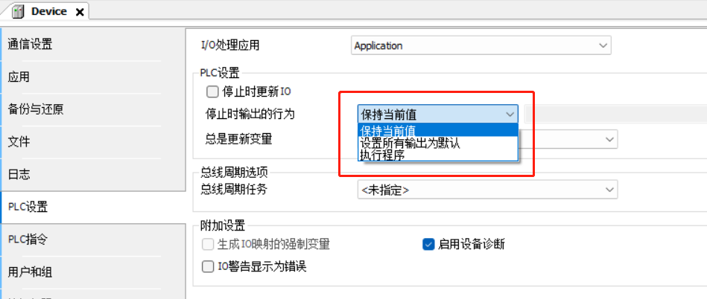

* + 1. Local extension module
* outline dimensional drawing

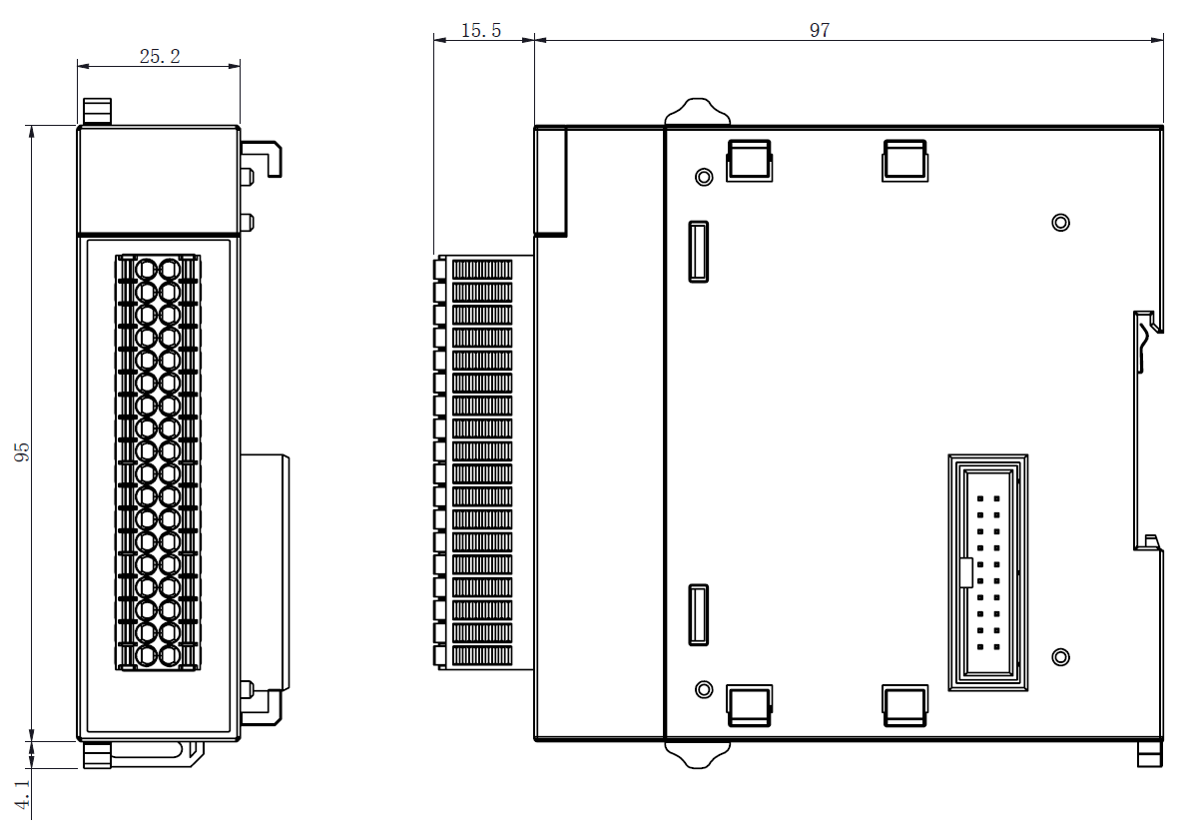

* Brief introduction of function

| model | classify | Product description |
| --- | --- | --- |
| K0-16DI | digital quantity  module | K0 series; 16 digital input modules; |
| K0-16DO-N | K0 series; 16 digital output modules; NPN transistor type; |
| K0-16DO-P | K0 series; 16 digital output modules; PNP transistor type; |
| K0-32DI | K0 series; 32 digital input modules; |
| K0-16DO-R | K0 series; 16 digital output modules; Relay type; |
| K0-32DO-N | K0 series; 32 digital output modules; NPN transistor type; |
| K0-32DO-P | K0 series; 32 digital output modules; PNP transistor type; |
| K0-4HAI-B | analog quantity  module | K0 series; Four analog high-precision input modules; 16 bit resolution; Voltage or current, 4-20ma/0-20ma/10VDC/5VDC/0 ~ 10VDC/0 ~ 5VDC/1 ~ 5VDC; |
| K0-4HAO-B | K0 series; Four analog high-precision output modules; 16 bit resolution; Voltage or current, 4-20ma/0-20ma/10VDC/0 ~ 10VDC; |

* Software function description

|  |  |  |
| --- | --- | --- |
| serial number | function | explain |
| one | Power-off hold function | The controller comes with UPS, and the power-off holding area realizes the power-off holding function. |
| 2 | System time function | If there is no battery in the controller, the system time will be restored to the initial time after power failure and restart. |

* + 1. IObus parameter description
* parameter

Method 1: View it in the ErrorID in "Lavichip.LACIOBus.Internal Parameter" in LAC100 IOBus page.

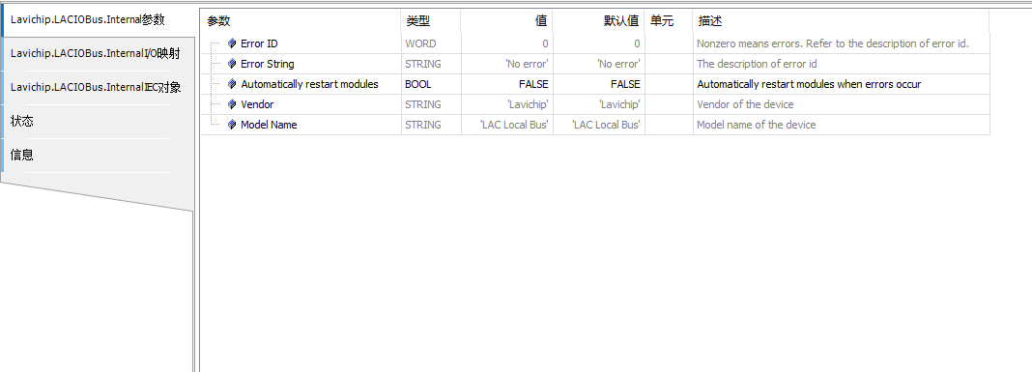

|  |  |  |  |
| --- | --- | --- | --- |
| parameter | Read-write type | Numerical value (decimal) | description of parameter |
| Error ID | read only |  | Extended bus error state |
| 0 | No error |
| three | The hardware topology is empty, and no module is connected to the coupler. |
| four | The number of modules configured in the upper computer development environment is inconsistent with the number of modules connected by hardware extension. |
| five | The order of modules configured in the upper computer development environment is inconsistent with that of modules connected by hardware extension. |
| six | Error in switching Enumeration state to Configuration state. |
| seven | Error in Configuration status communication. |
| eight | Switch Configuration state to Cycle state. |
| nine | Error in Cycle status communication. |

Method 2:

Module name. State to view the current status.

Example: k0 \_ 32do \_ n.softwareversion. ; When the state value is 8, the module enters the normal operation state.

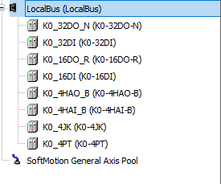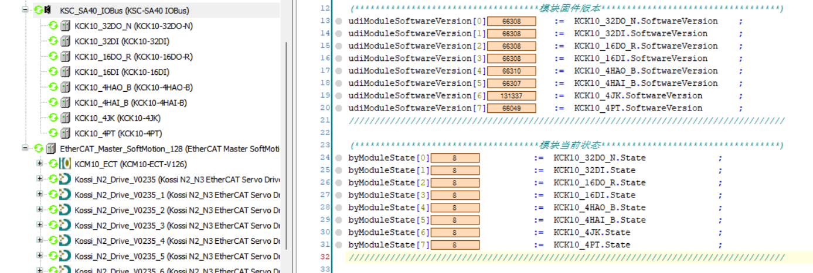

* Module firmware version
* Method 1:
* Module name. SoftwareVersion;

For example: K0\_32DO\_N.SoftwareVersion; You can see the current firmware version of the first expansion module of SA40.



Method 2:

Login status, enter the page below to view.

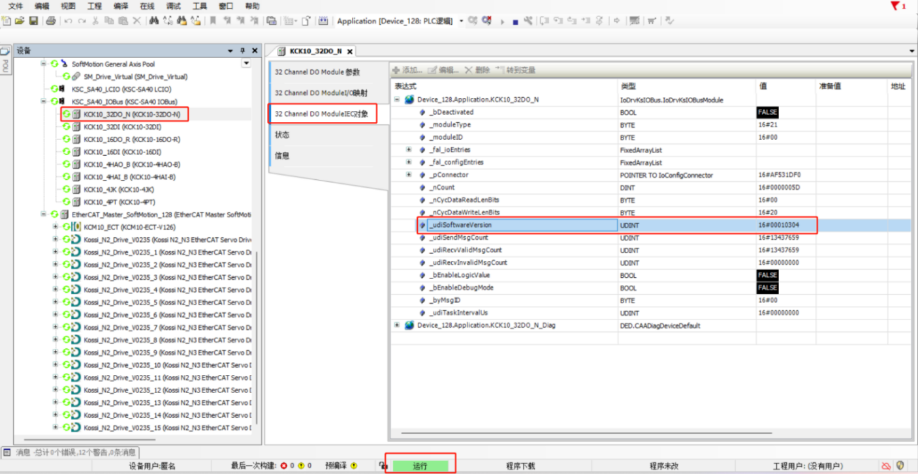

3.7.6 Remote expansion module

* Appearance dimension diagram

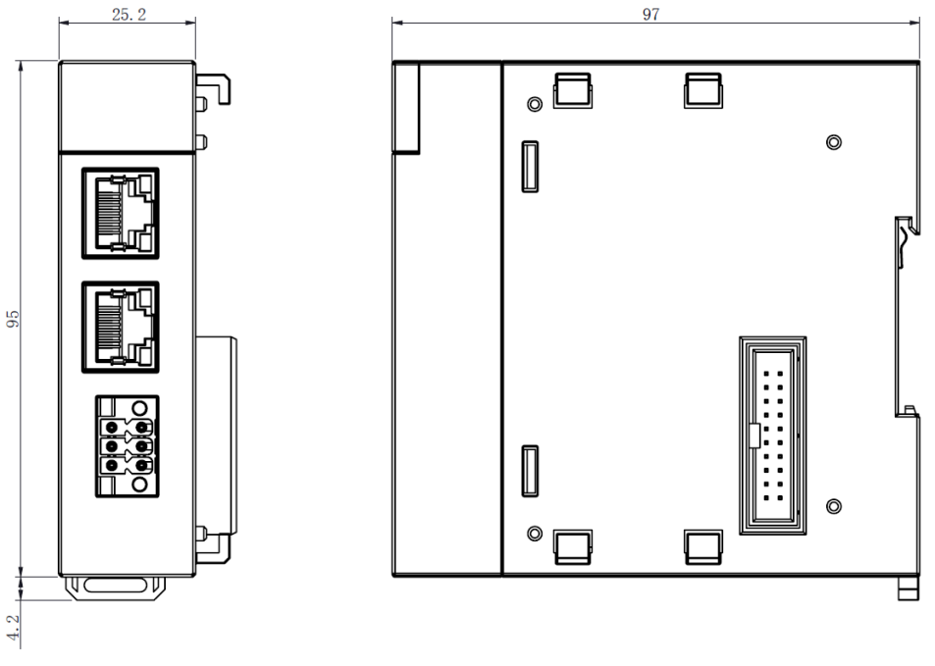

* Brief introduction of function

|  |  |  |
| --- | --- | --- |
| model | classify | Product description |
| K0-ECT | Coupler module | K0 series; EtherCAT bus; 2 RJ45 communication ports; 24VDC power supply |

1. Installation and disassembly
   1. Wiring instructions

It is recommended to use cables with a wire diameter of 0.2 ~ 1.5 mm. The inner diameter of the tube-type cold-pressed terminal is at least 1.5, and the length of the exposed metal tube is at least 10 mm. The parameters of the cold-pressed terminal are as follows:

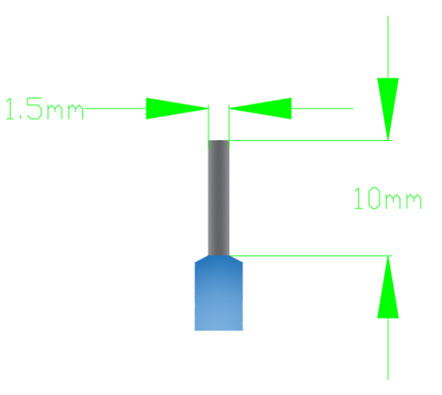

* 1. Communication related wiring

EtherCAT bus communication uses shielded network cable to transmit network data, without short circuit, dislocation and poor contact; The length of cables between devices should not exceed 100m, which will lead to signal attenuation and affect normal communication. The following specifications of network cable are recommended:

|  |  |
| --- | --- |
| Item | specifications |
| Cable type | Elastic crossover cable, S-FTP, Category 5 cable |
| Satisfied standard | EIA/TIA568A，EN50173，ISO/IEC11801  EIA/TI Abulletin TSB，EIA/TIA SB40-A&TSB36 |
| Conductor section | AWG26 |
| Conductor type | unshielded twisted pair |
| wire pair | four |

1. Pin definition of bus communication cable

|  |  |  |  |  |  |  |  |  |  |
| --- | --- | --- | --- | --- | --- | --- | --- | --- | --- |
| pin | one | 2 | three | four | five | six | seven | eight | shell |
| signal | TD+ | TD- | RD+ | / | / | RD- | / | / | block |

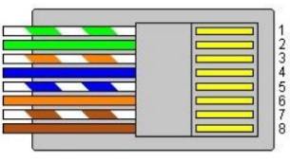

* 1. matters need attention

If a module is difficult to install, do not use brute force to install it, so as not to damage the current module or other modules; The module should be removed from the guide rail, and the module should be checked for abnormalities (such as foreign body blockage) before being inserted.

1. Module connection
   1. Connection of power supply, controller and local I/O expansion module

LAC100 series products can be seamlessly connected with K0 series products of our company, and the controller, power supply and module are closely connected through internal buckles.

* 1. Rail mounting
* Pull out all the buckles (as shown in the figure) on the back of all modules in the module group. Pull it until it clicks.

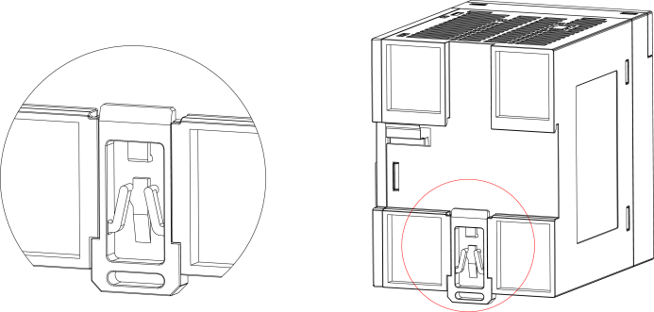

Figure pull-down buckle

* Hang the fixing claw on the upper side of the module on the upper side of the guide rail as shown in Figure A, and press the module group firmly in Figure B until it is completely embedded in the guide rail.

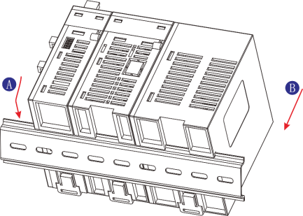

Figure Installation Module 1

* After locking the buckle of the module, insert it into the guide rail. Press upward until it clicks, as shown in the figure. If your fingers can't reach the buckle, you should borrow it.

Tools such as screwdriver, remember to use large torque.

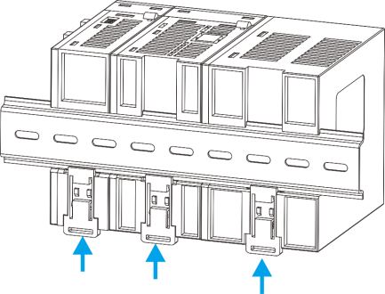

Figure Installation Module 2

* 1. Use the battery and replace the battery
* Use batteries

1. Open the battery box cover

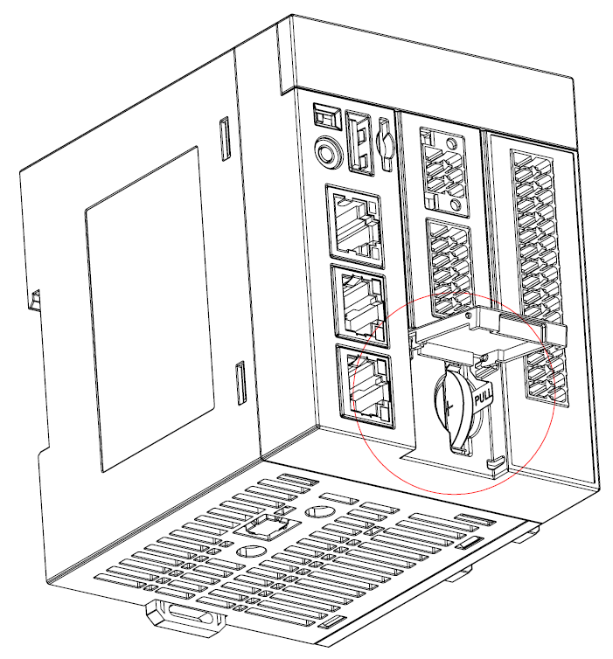

1. Pull out the insulating gasket on the right side of the battery to energize the CR2032 battery.

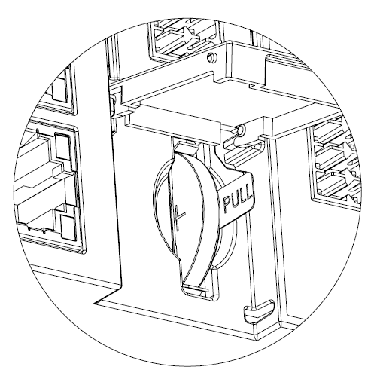

* Replace the battery

1. Hold the adhesive tape fixed on the CR2032 battery and pull it out.
2. Use CR2032 spare battery, gently insert it into the battery card slot and cover the battery box.
3. Communication connection
   1. EtherCAT/Modbus TCP bus connection

LAC100 series network interfaces support EtherCAT, ModbusTCP and ModbusRTU network communication modes at the same time, and can be configured.

The programming software configures the working mode of the network interface, and the EtherCAT mode supports the conventional EtherCAT device connection communication. Modbus TCP mode

Modbus-TCP master/slave protocol is supported under.

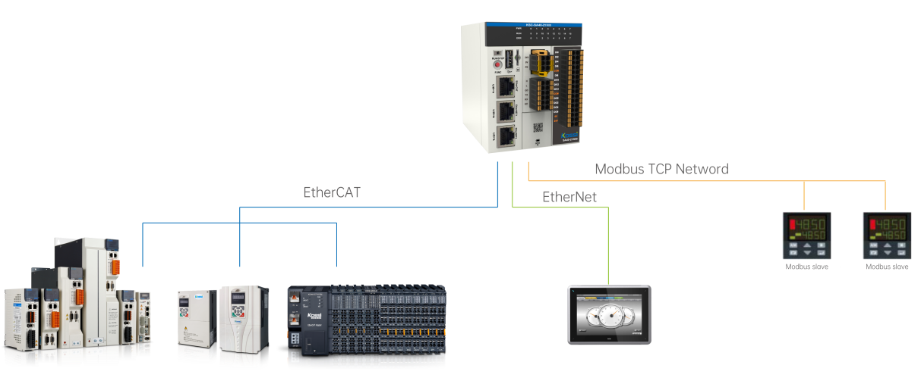

* 1. RS232/RS485 communication connection

The RS485 communication interface adopts plug-in terminal. Refer to Chapter 3.6 for the definition of the interface, and connect it as required.

* 1. Monitoring connection via Ethernet

LAC100 series integrates MODBUS-TCP and MODBUS-RTU functions to provide data access interface for upper communication.

1. Point-to-point connection with PC, HMI, etc. through Ethernet cable.

2. Connect to a hub or switch through an Ethernet cable, and then connect with network devices such as PC and HMI to realize multipoint connection.

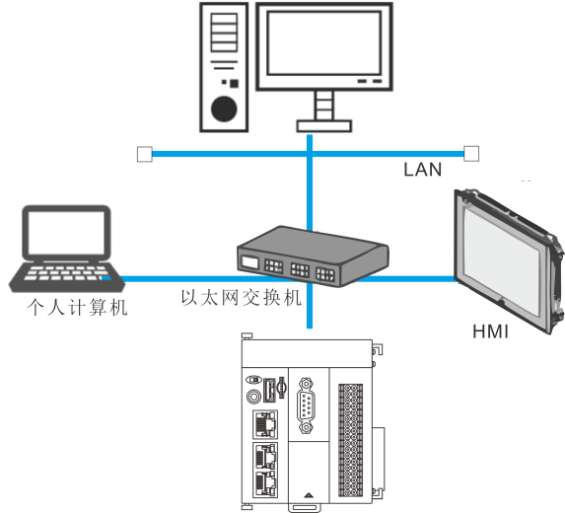

Figure LAC100 series is connected to other devices through switches.

1. Web page operation

Note: The specific supported browsers and versions are as follows:

* Chrome: 23-113
* Edge: 12-110
* Safari: 6-16.3 (including TP version)
* Firefox: 21-112
* Opera: 15-94
* IE: 10-11
  1. Log on to the web

1. Open a browser (edge and chrome are recommended) and enter the default IP 192.168.1.92:8090 to log in to the webpage.

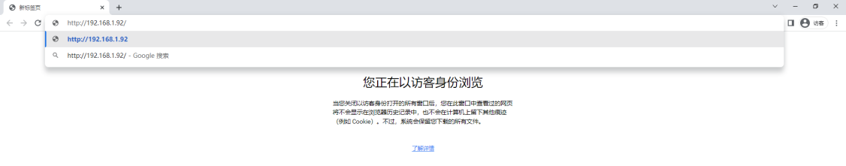

1. Try to log in with the default user name "admin" and the default password is "12345678".

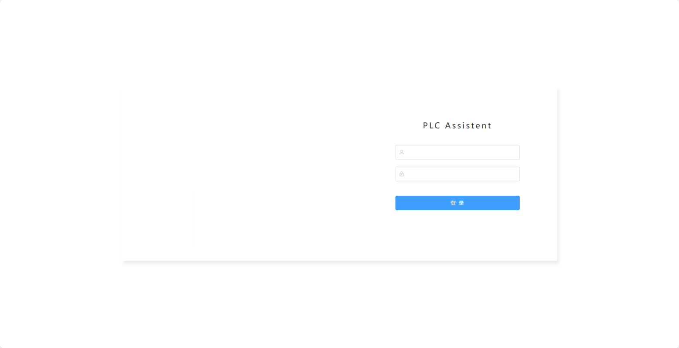

* 1. Controller information viewing, and controlling local IO.

(Note: IO status has been output, and it will only be effective when the program stops.)

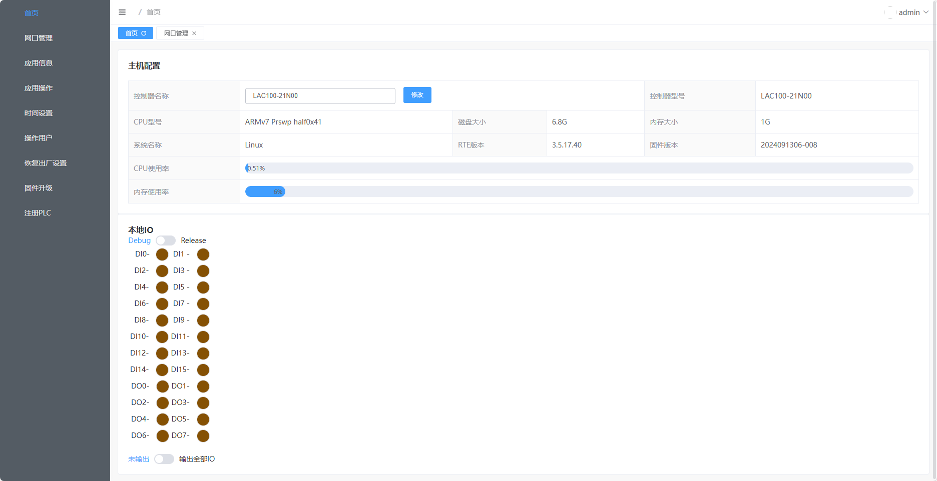

* 1. IP settings

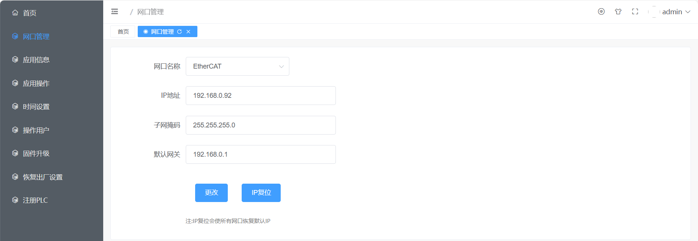

* 1. Application information

1. The upper part is the running status of the application program and the display status of the digital tube (LED);
2. The log below is the error log of runtime.

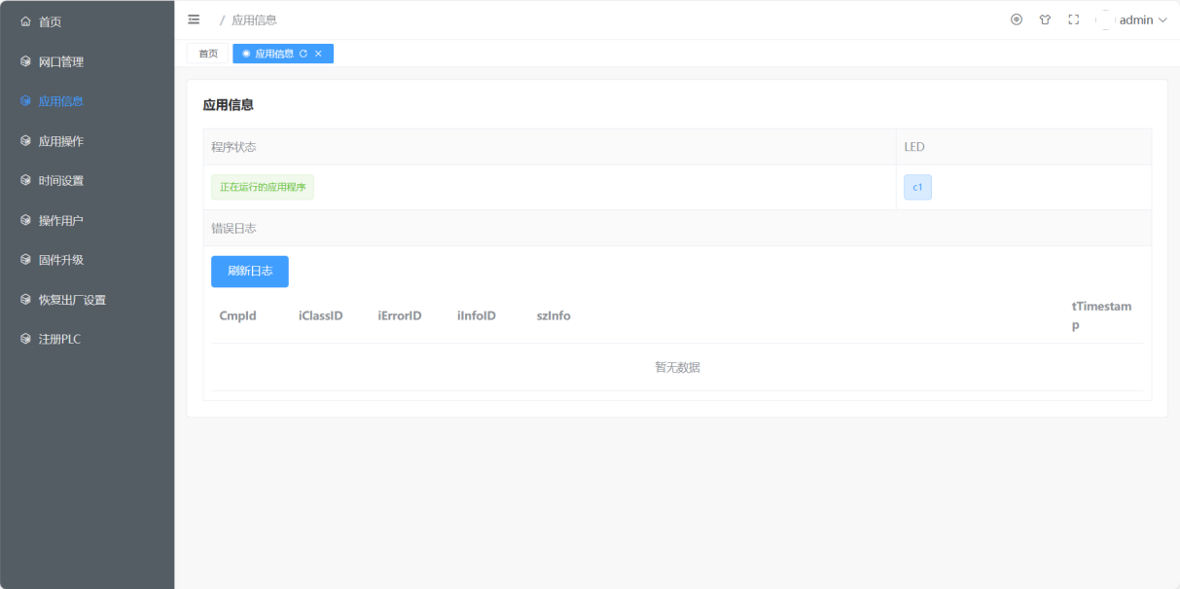

* 1. Application operation

1. The button on the left side of the application operation is the control program button, which is effective when dip switch is turned to the left side, except for restarting;
2. The uploading program on the right is an update Application. After the offline program is generated by codesys project, the Application.app and Application.crc files can be put into the newly-built application folder and compressed into zip files. After the upload is completed, it will automatically restart if the update is successful.

Note: Only the default program name Application is supported, and the folder name cannot be modified;

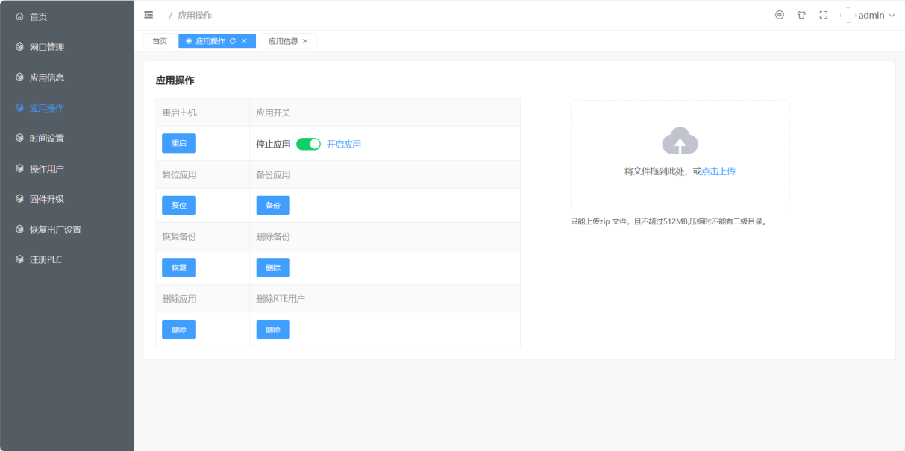

* 1. System time setting

Click Set to pop up the time setting window, set the required time and then click.

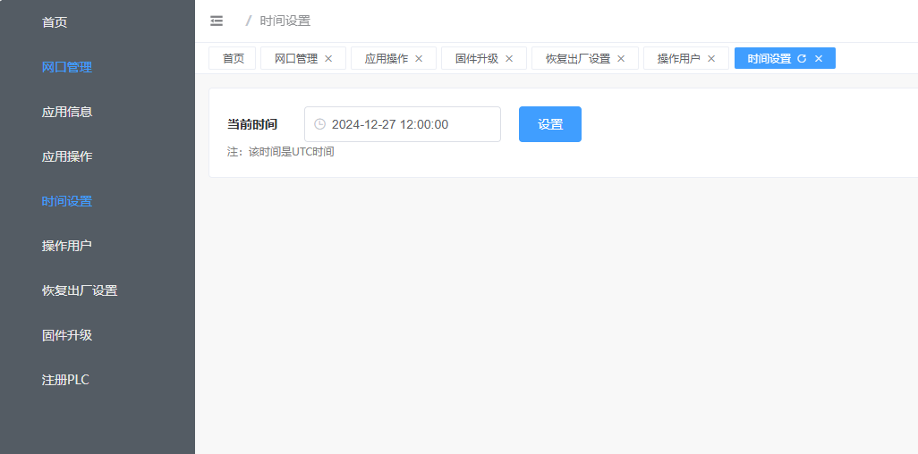

* 1. Web user operation

1. Add users
2. Modify user name
3. Delete users (Note: Only users with small user ID can delete users with large user ID)

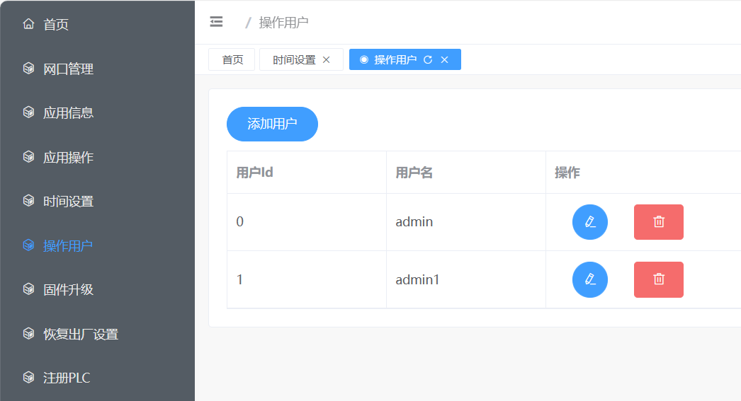

* 1. Firmware upgrade

After obtaining the firmware of. des suffix from the supplier; Select here, enter the 6-digit KEY behind the file name key after selection, and then click Upload. If the update is successful after uploading, it will automatically restart;

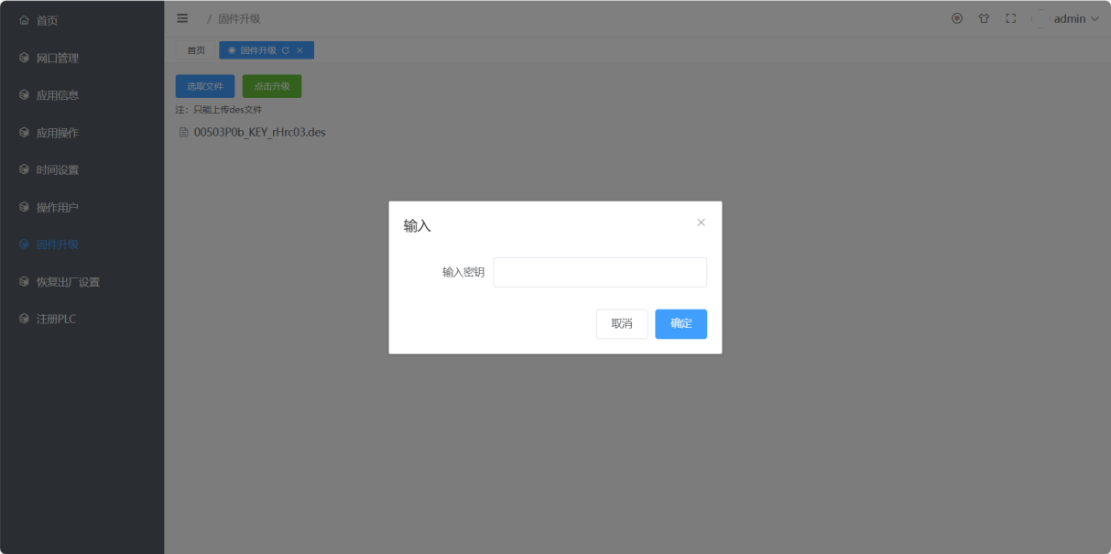

* 1. Restore factory settings

After the program is set to stop state, click the button to restore the factory settings, and it will automatically restart after the recovery is successful.

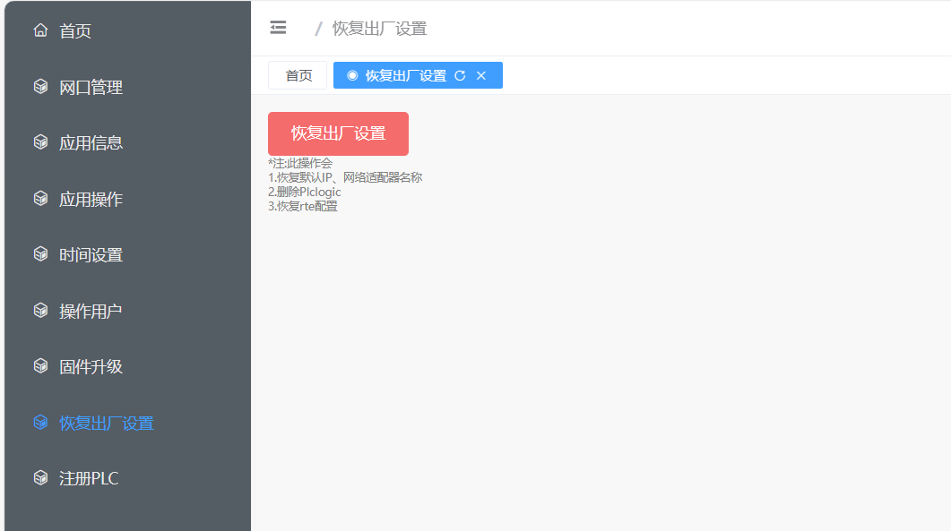

* 1. Registered PLC

Used to register PLC. Unregistered PLC can communicate with suppliers to register.

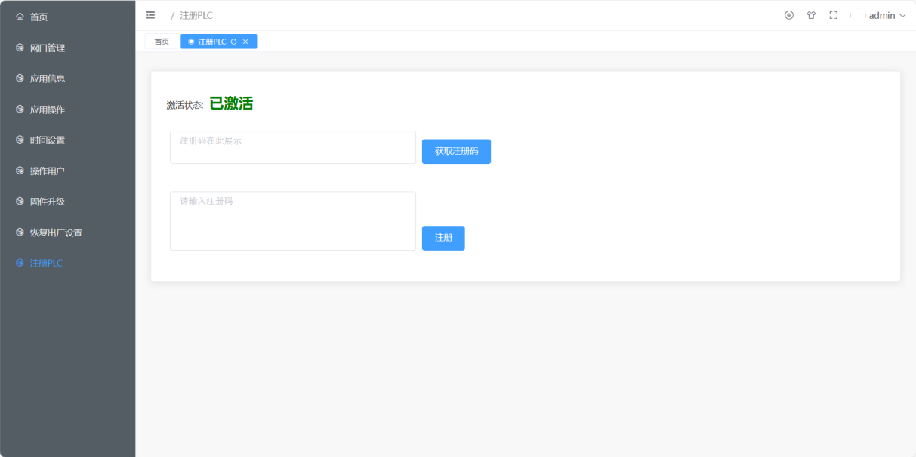

1. Programming example

The programming examples of LAC100-21N00, an L2 driver, a K0-ECT coupler, and several K0-series extension modules realize the local IO input and output of the controller, control an L2 driver to perform Cam synchronous motion, and LAC100-21N00 directly connects the input and output of the extension module, and uses the input and output of the extension module in cooperation with K0-ECT.

* 1. Preparation before programming
* software

1. Install the programming software CODESYS； on a PC that meets the installation environment;

2. Start the CODESYS software and install the device description file and function library.

* hardware

According to the actual application scenario, the hardware is connected with LAC100-21N00 series controllers and L2 series drivers, and the power is supplied as required. In this programming example, the hardware device has a controller (LAC100-21N00). Connect the Ethernet interface of the controller to the PC with CODESYS software installed through the network.

* 1. Create a project and make programming configuration.

1. Double-click the CODESYS startup icon to open the programming software and create a new standard project on CODESYS.

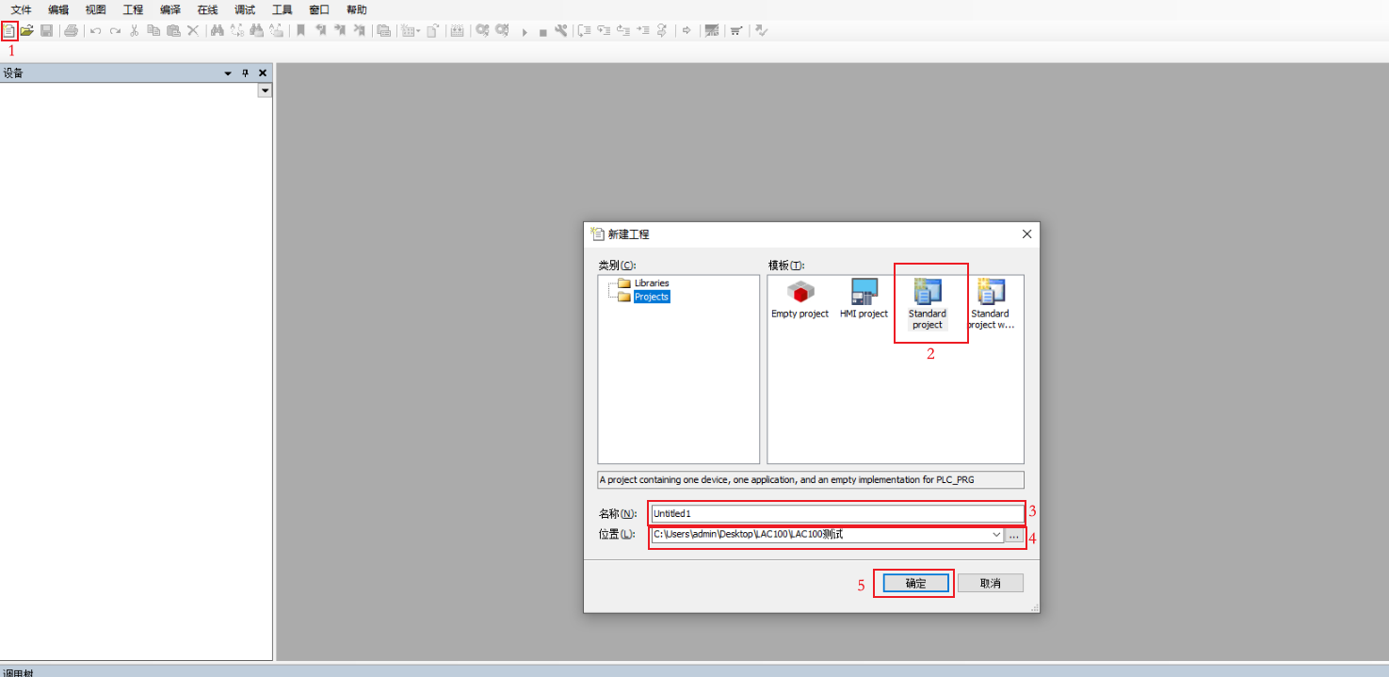

1) Click New.

2) Select standard items

3) Rename the project name

4) Select the project location

5) determine

1. Select controller and programming language

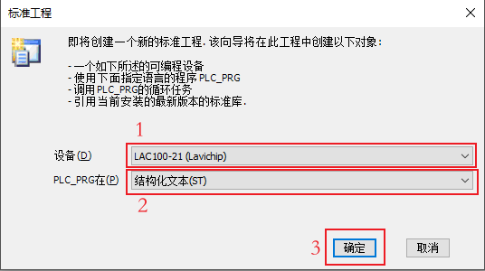

1. Select LAC100 controller.
2. Choose an appropriate programming language
3. sure
4. Connection controller

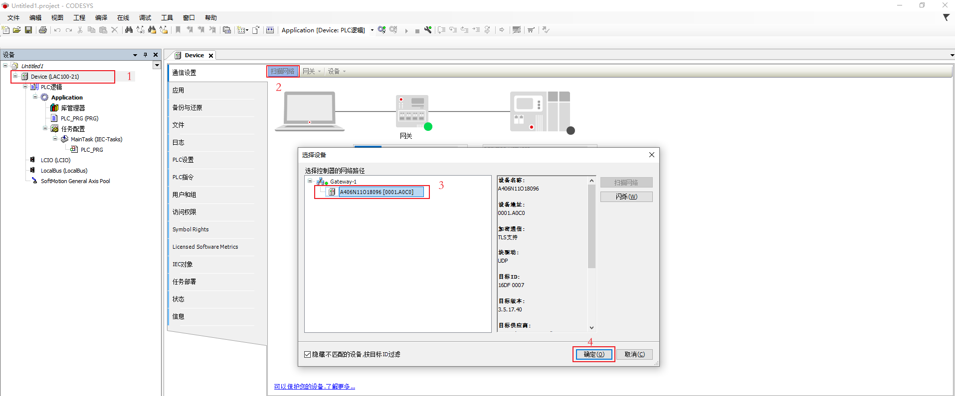

1. Double-click device
2. Select scan network
3. Select LAC100.
4. sure

Note: If there is a box below, you can choose "No" and do not authenticate.

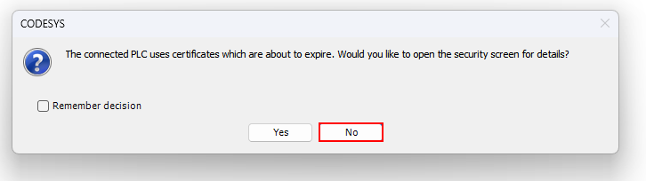

1. Local IO mapping

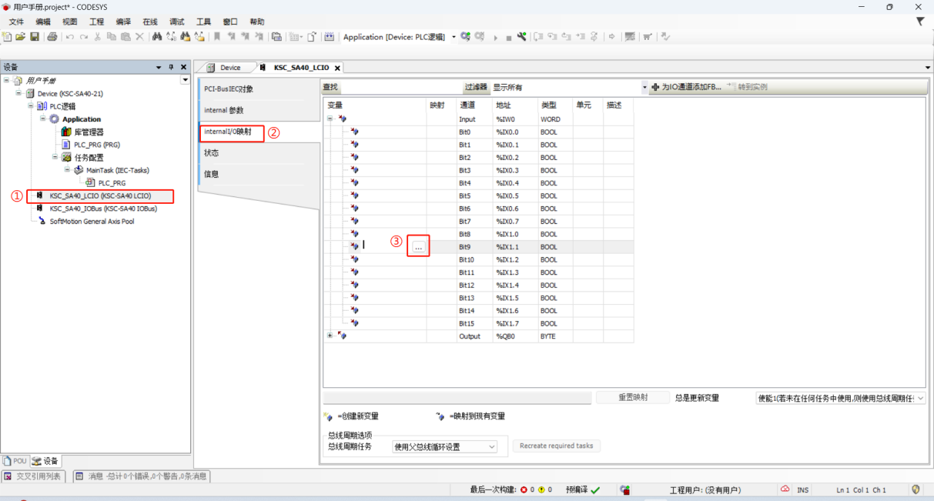

1. Double-click the device LAC100\_LCIO.
2. Select IO mapping.
3. Select the variable to be mapped.
4. Extension module directly connected after SA40 is added.

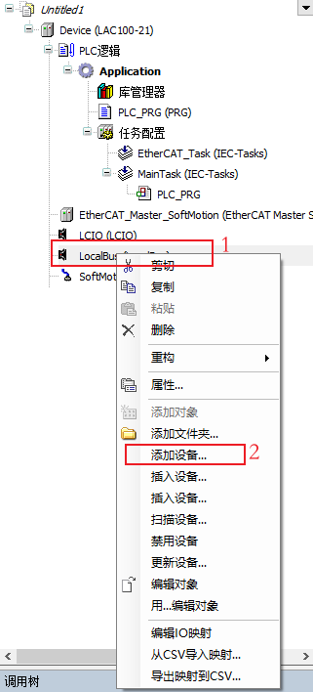 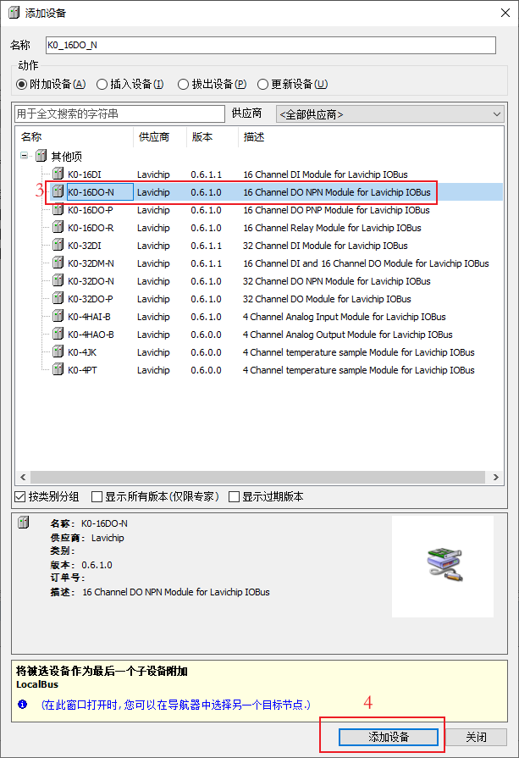

1. Right-click on LAC100\_IOBus device;
2. Select Add Device;
3. Select the module to be added;
4. Confirm adding equipment
5. Extension module directly connected after mapping variables to LAC100.

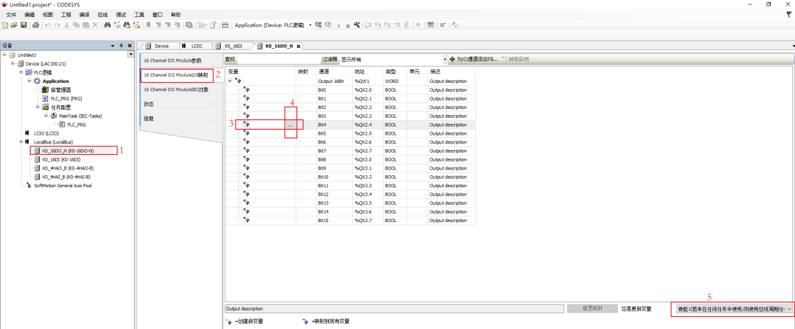

1. Double-click the device that needs variable mapping, taking K0\_16DO\_N as an example;
2. Click on the 16 Channel DO ModuleI/O map;
3. Double-click the channel to be mapped;
4. The option button ④ appears, click and select variables for mapping;
5. Change Enable 1 to Start 2.
6. Adding EtherCAT Master SoftMotion fieldbus to the equipment.

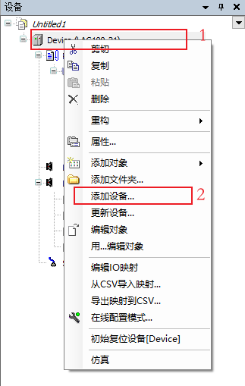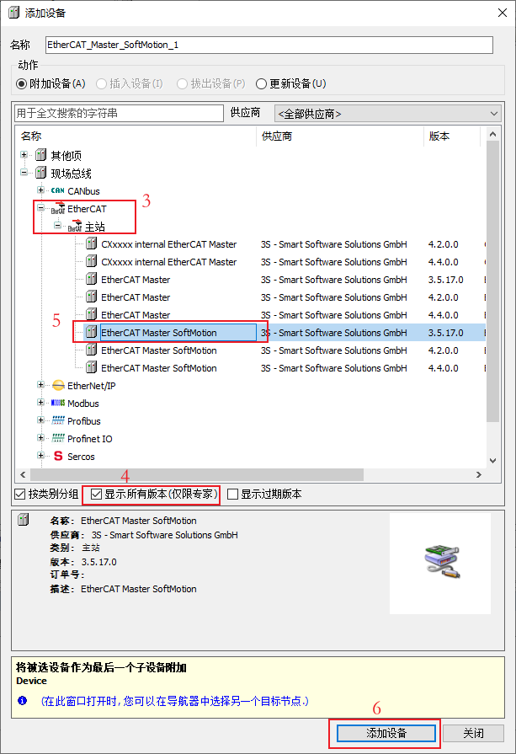

1. Right-click the LAC100 device.
2. Select Add Device from the pop-up menu.
3. Expand EtherCAT, master station.
4. Check Show All Versions.
5. Select ethercat master soft motion version 3.5.17.0.
6. Confirm adding equipment
7. Configure NIC network card in EtherCAT Master SoftMotion device.

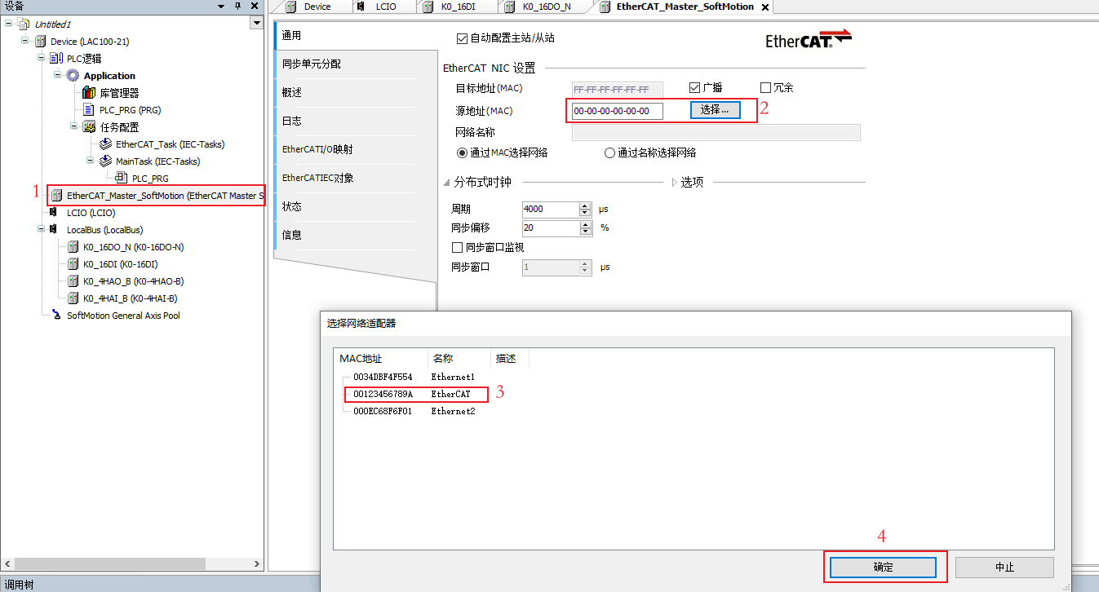

1. Double-click EtherCAT master station
2. Browse network card
3. Select EtherCAT network card.
4. confirm
5. Manually add slave stations in the EtherCAT Master SoftMotion fieldbus according to the hardware topology order. Adding slave stations can be done by manual addition and scanning. The manual addition method is introduced here. The hardware topology is LAC100-21N00→K0-ECT→L2 servo, so the K0-ECT coupler and its later expansion module are added first, and then the L2 and 402 axes are added.

* Add K0-ECT coupler and its extension module.

1. **Add K0-ECT coupler**

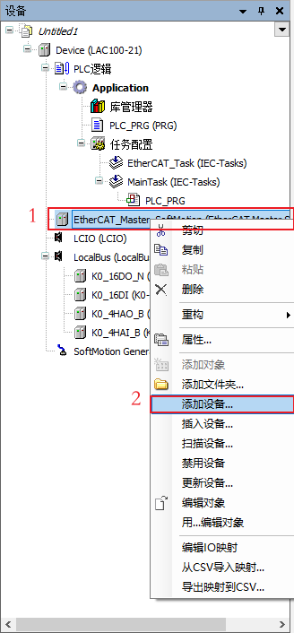 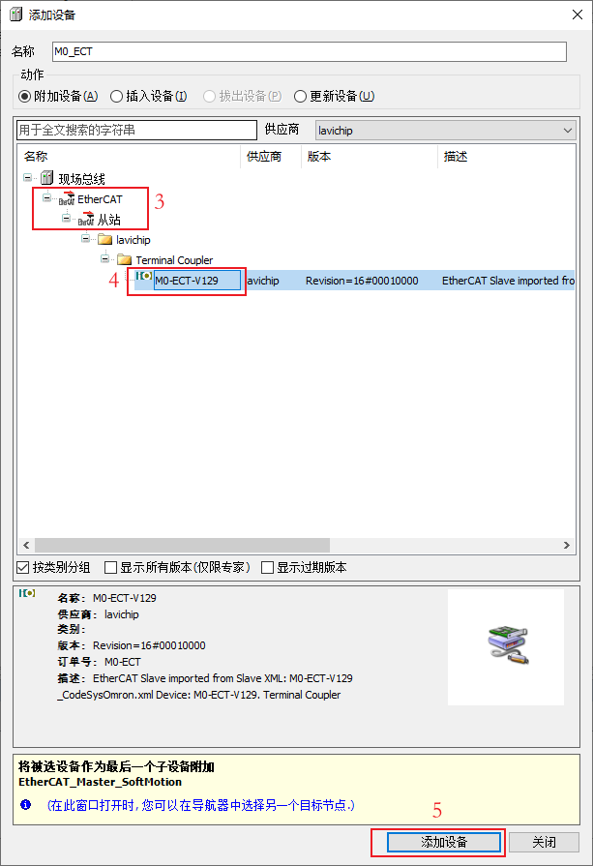

1. Right-click EtherCAT master station;
2. Select Add Device.
3. Select expand slave station.
4. Select K0-ECT coupler.
5. confirm
6. **Add extension module**

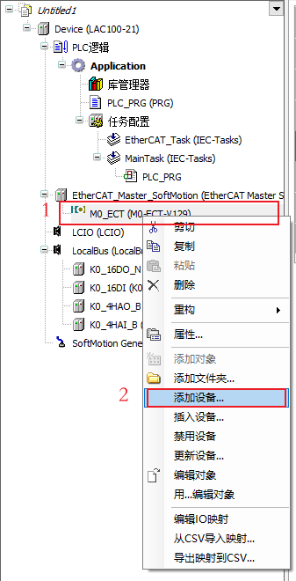 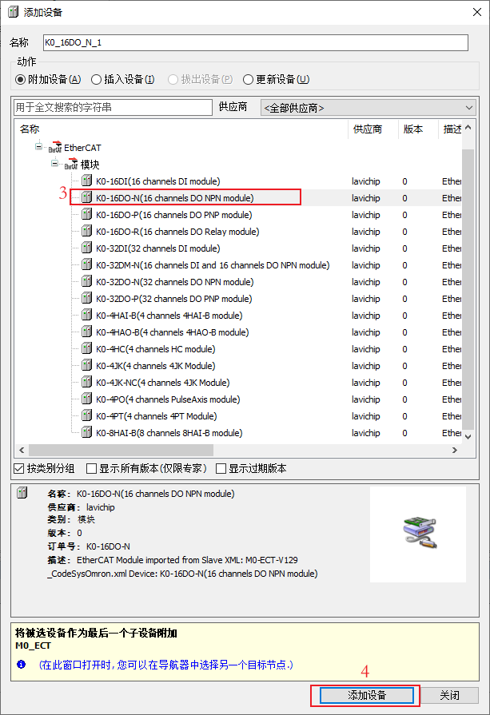

1. Right-click K0-ECT coupler;
2. Select Add Device.
3. Select the required extension module as needed.
4. confirm
5. **Mapping variable**

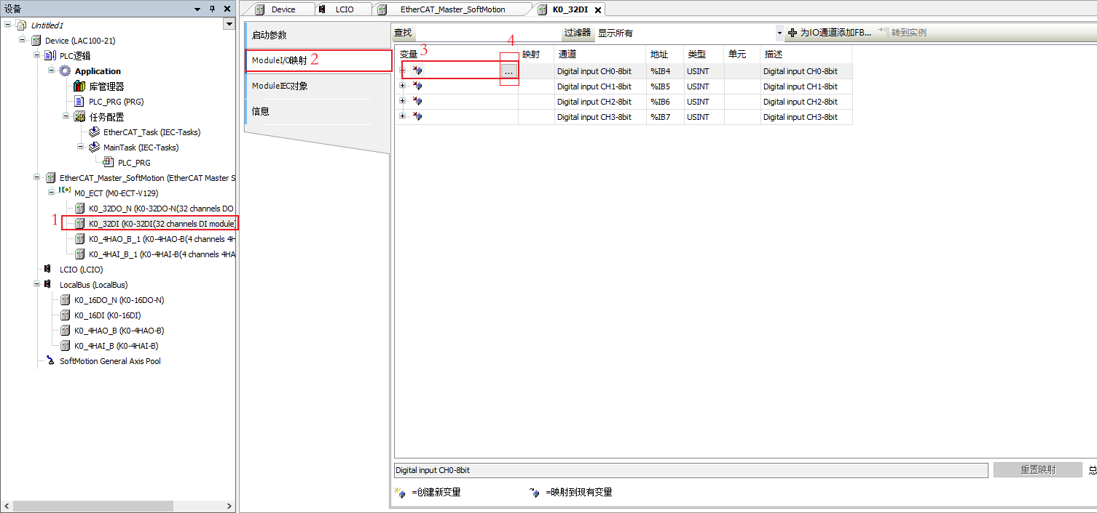

1. Double-click the device that needs variable mapping;
2. Click MoudleI/O mapping;
3. Double-click the channel to be mapped;
4. The option button ④ appears, click and select variables for mapping;
5. Change Enable 1 to Start 2.

* Add servo and 402 axis

1. **Add servo**

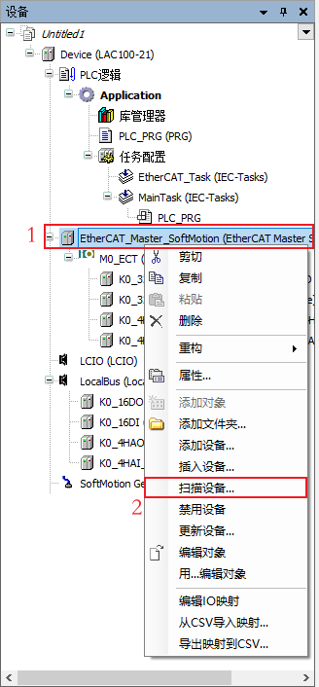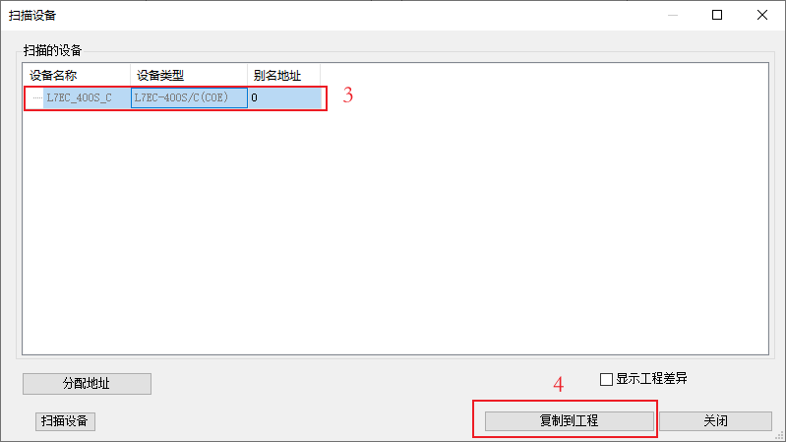

1. Right-click EtherCAT master station;
2. Select a scanning device
3. Select expand slave station.
4. Selective servo
5. confirm
6. **Add 402 axis**

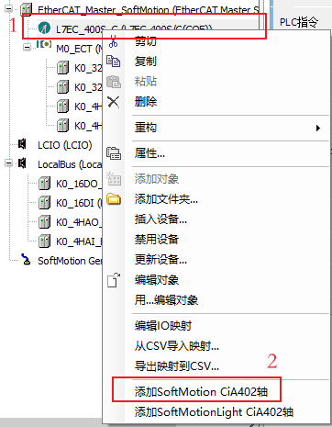

1. Right-click on the slave station
2. Select axis 402
3. **Configure the gear ratio according to the actual situation.**

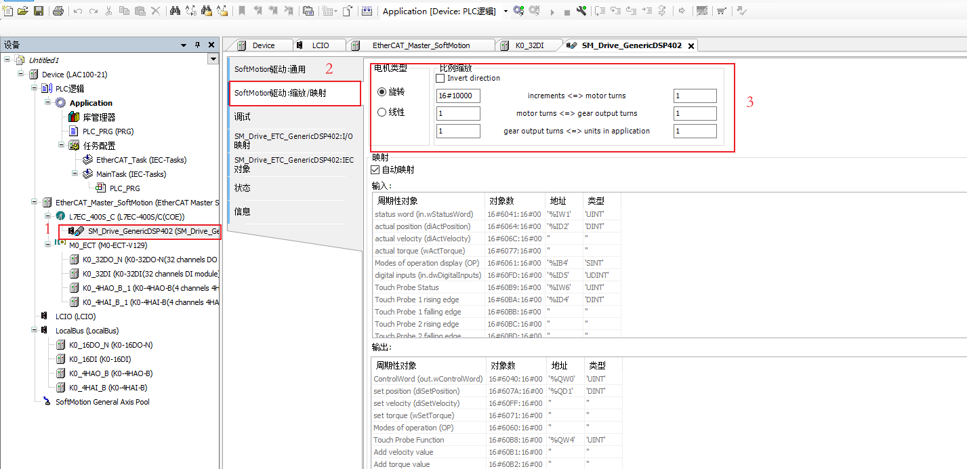

1. Double-click axis 402
2. Gear selection ratio mapping
3. Fill in the gear ratio according to the actual situation
4. Add POU

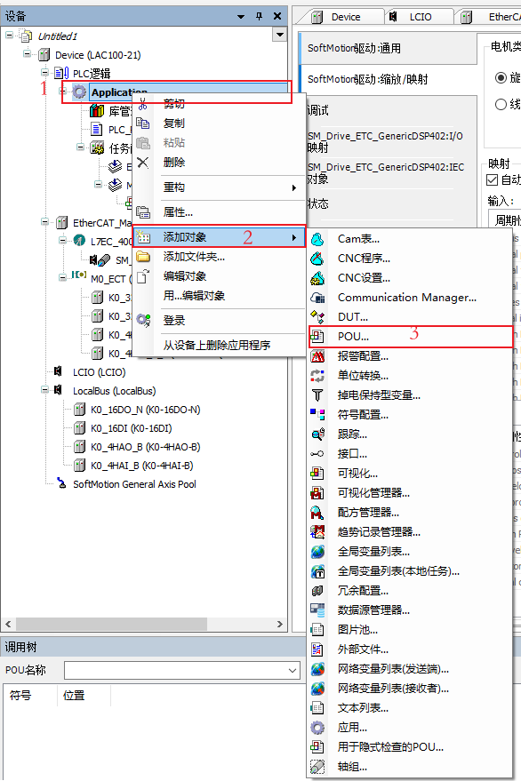 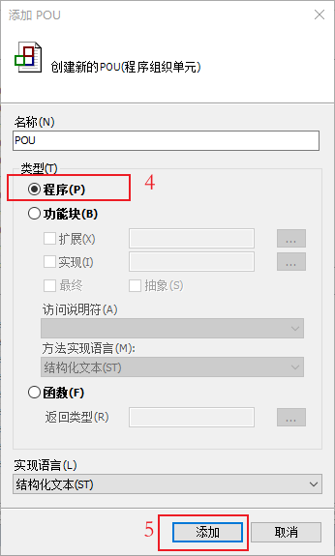

1. Right click Application
2. Select add object
3. Select POU
4. Select the appropriate POU and implementation language.
5. Confirm add
6. Add POU to the task, and it is suggested that the program running in the EtherCAT slave station be added to EtherCAT\_Task.

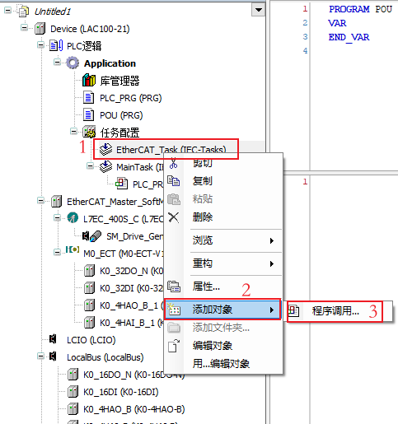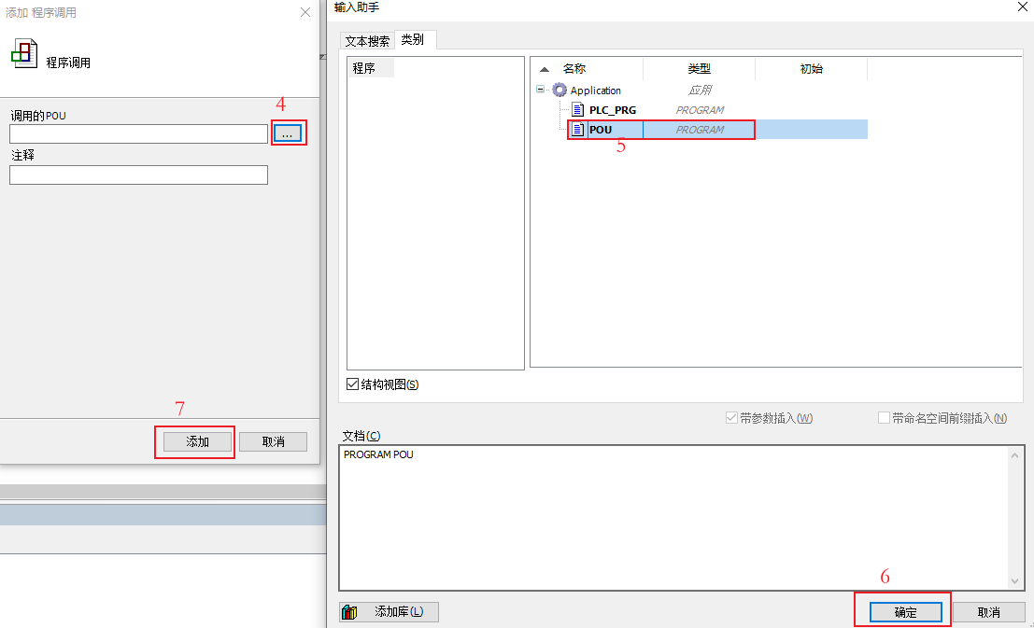

1. Right-click the task to be added, and select EtherCAT\_Task here;
2. Select Add Object;
3. Select a program call;
4. Select options;
5. Select the POU； to be added;
6. Confirm;
7. Confirm add
8. Modify the task priority, which is divided into 32 levels, with 0 as the highest (note: don't set the task priority to the same level when there are multiple tasks).

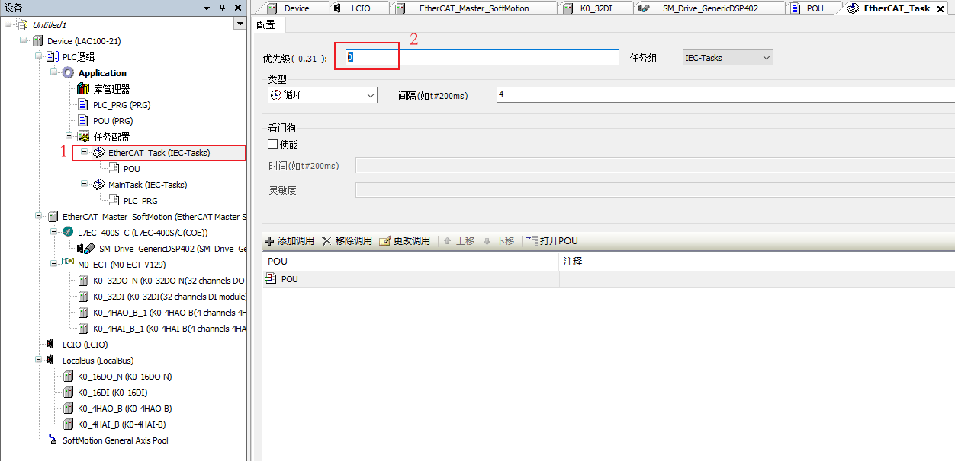

1. Double-click EtherCAT\_Task;
2. Input priority
3. Modify the task cycle, here is an example of using DC.

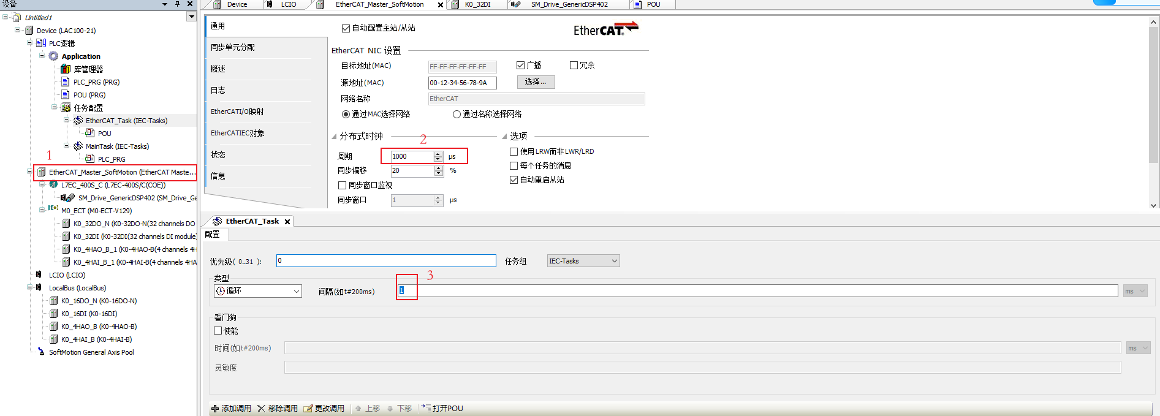

1. Double-click EtherCAT\_Master\_Softmotion;
2. Modify the distributed clock cycle;
3. In EtherCAT\_Task, synchronous change of cycle period can be observed.
4. Configure bus task

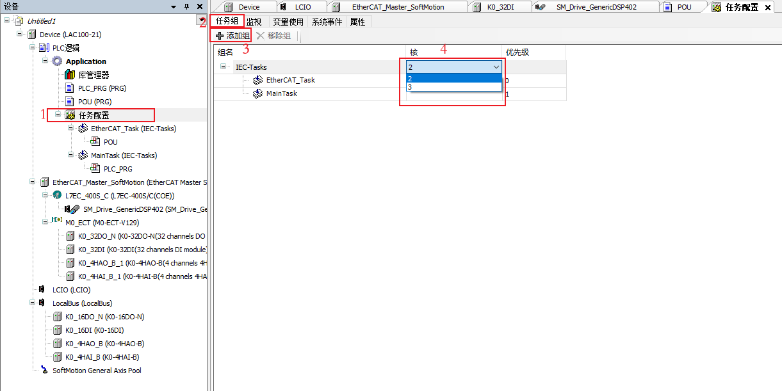

1. Double-click task management
2. Select task group
3. Add a task group and move the EtherCAT\_Task task to the newly created task group.
4. Set the core where the task group is located.
   1. Program compilation, operation and debugging
5. Compiler.

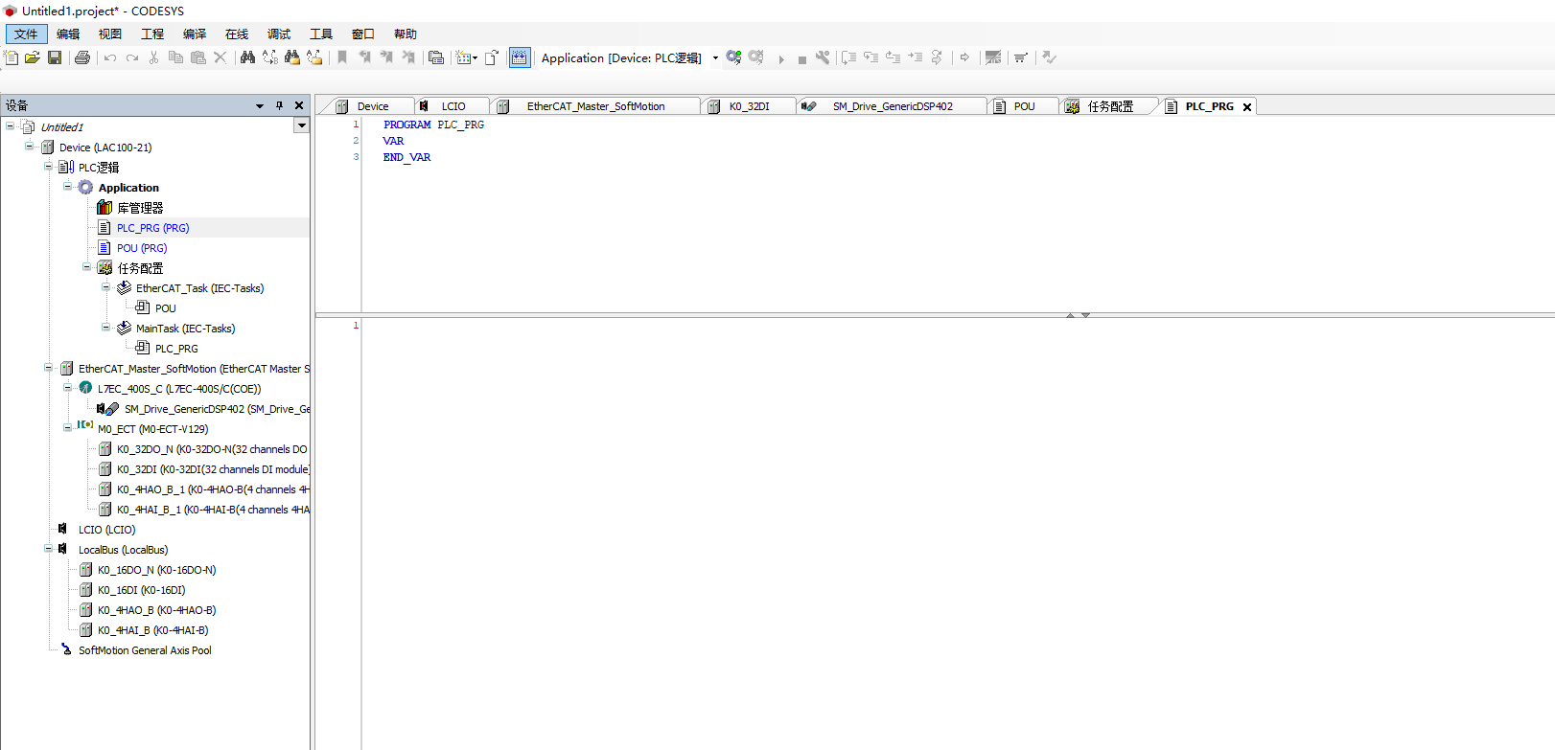

1. Log in and connect with LAC100-21N00 controller, and download the application.

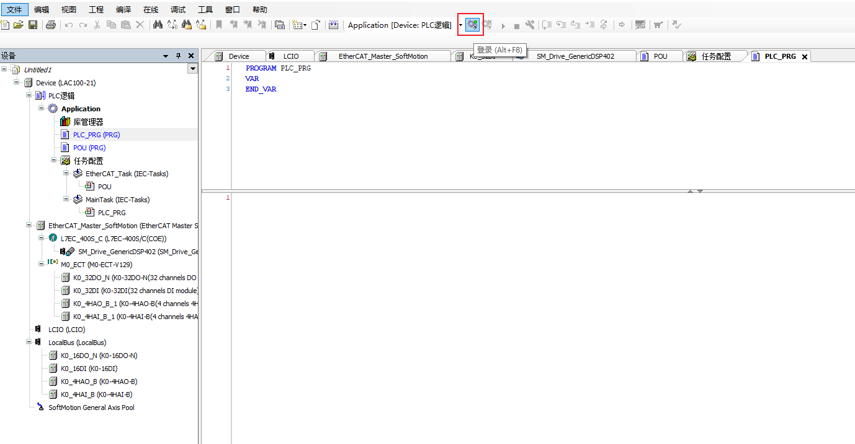

1. After the download is successful, click the program run button shown below.

Run the application. If the device (sub-device) is normal, the_3S.CoDeSys.DefaultNavigators.Resources.Module_Okicon will appear in front of the device, and the "_3S.CoDeSys.DefaultNavigators.Resources.Module_Diagnosis" and "_3S.CoDeSys.DefaultNavigators.Resources.Module_Error" icons will appear if the device is not normal or does not support it.

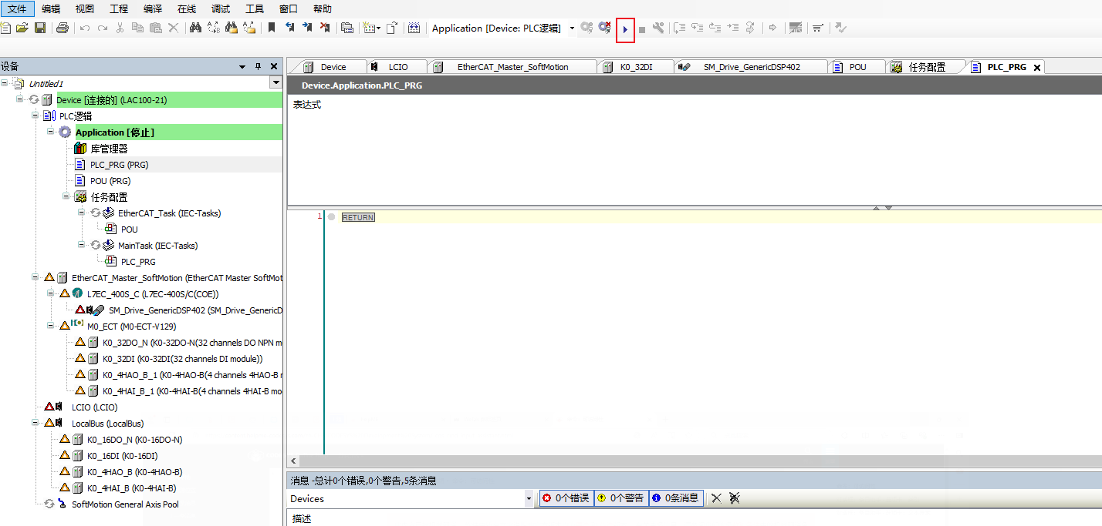

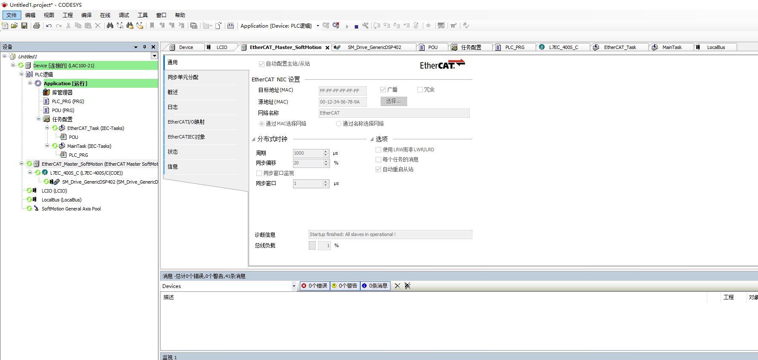

Version number: V1.4

Shenzhen lavichip technology co., ltd

Zhizao center

Headquarters address

Floor 4, Building B, Juji U Valley Manufacturing Innovation Park, Houting Community, Shajing Street, Baoan District, Shenzhen

facsimile

Uniform Resource Locator(URL)

mailbox

Shenzhen Lavichip Technology Co.,Ltd

6th Floor, Building 15, Haichuang Dazu Robot Manufacturing City, No.3, No.2 Industrial Avenue, Xihai Village, Beijiao Town, Shunde District, Foshan City, Guangdong Province

www.lavichip.com

sa01@lavichip.com

0755-29982196



**0755-29492749**